Mrs. K.S.K.College,Beed
DEPARTMENT OF PHYSICS
Photogallery (2018-2019)
Rajiv Gandhi Energy Conservation Day
On 20, August 2018, On the occasion of Rajiv Gandhi Akshy Urja Din,Department organized elocution competition, for the college students. The main aim of this programme was to create awareness about the electricity conservation.
This competition was inaugurated by principal of college, Dr. Deepa Kshirsagar. vice Principal Dr. A.S. Hange, Prof. Sayyad Lala, P.G. Director, Dr. Rekha Gulve, Supervisor Prof. Khande S.S presided over the function. Dr. S.V. kshirsagar, vice Principal and head of the department of physics guided for Competition. Dr. Deepa kshirsagar delivered an inaugural speech. In the inaugural Speech, she said that, Today, there is scarcity of energy and the demand for energy is increasing, Due to Increasing population, change of lifestyle due to globalization, Increasing use of Electronic Devices, It is a collective responsibility to overcome this problem. Everyone should fulfill this responsibility. This is a campaign in terms of energy development, only then will be the development of the individual and nation. Dr. P.R. Maheshmalkar delivered an introductory speech. She declared the picture of departmental activities & Aim behind the competition through her speech. 16 Students were participated in the competition.
The subjects for this competition were
- Energy generation methods
- Various sources of Energy
- Energy saving and nation development
- Energy Problems and solutions ahead of future India
The competition was judged by the physics teacher Prof. Shastri S.G. & Prof. Malode S.S. From all Participants 4 Participants selected for 1st, 2nd, 3rd& Consolation prize & awards were given by the hands of respected Dias. First Prize – Kute Vishal Bhausaheb, Second Prize – Kshirsagar Minal Nagesh, Third Prize – Kudke Amruta Tukaram, Consolation prize- Suryanshi Sayali Dattatrya
This programmes was anchored by Dr. P.R. Maheshmalkar & Vote of thanks was proposed by Prof. Kokate R.Y. All B.sc. I, II, III year (50) students were present for this programme. In this programme, Physics Dept., college staff, students also involved & Co-operated. Efforts are made by Prof. A.D. Jadhav and Shree.Darade Vishnu for completion of this programme.

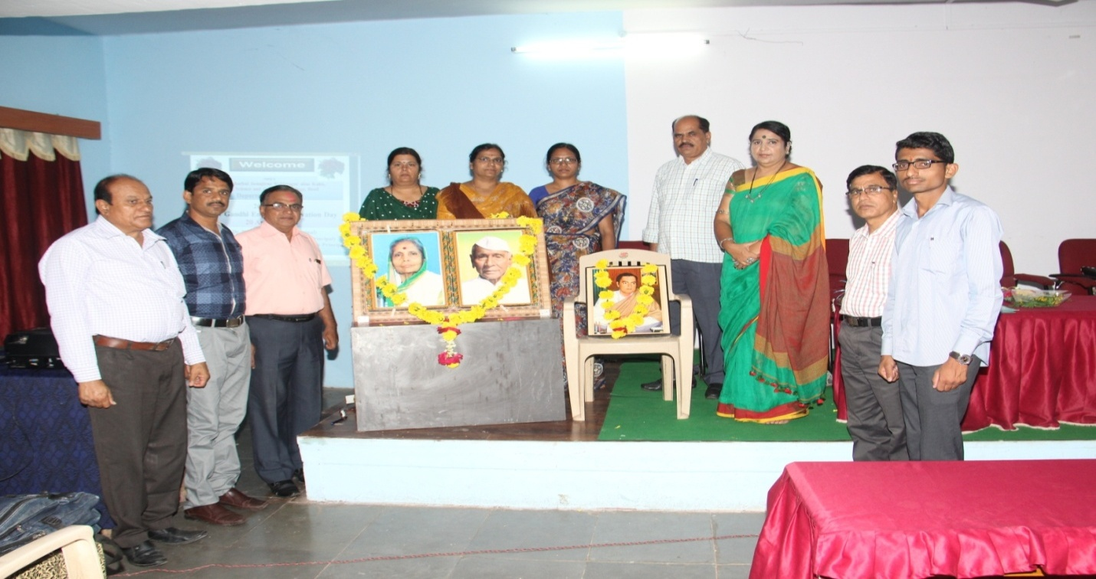
On the occasion of Rajiv Gandhi Akshy Urja Din, Hon’ble principal Dr. Deepa Kshirsagar. vice Principal Dr. A.S. HangeP.G. Director, Dr. Rekha Gulve and Departmental Staff
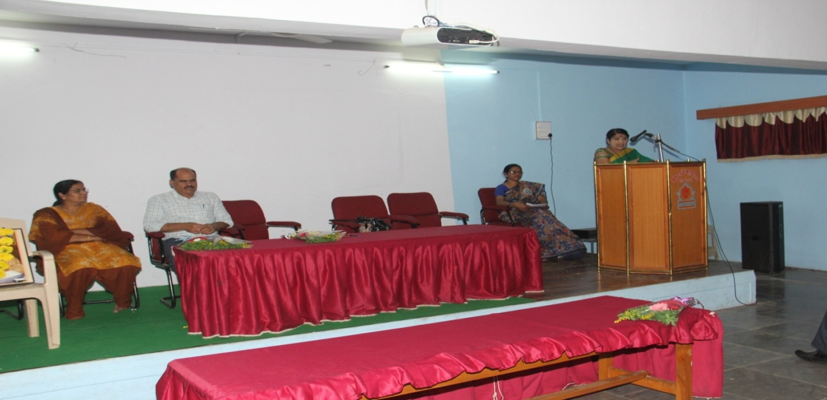
Hon’ble Principal Dr. Deepa Kshirsagar, deliveringinaugural speech
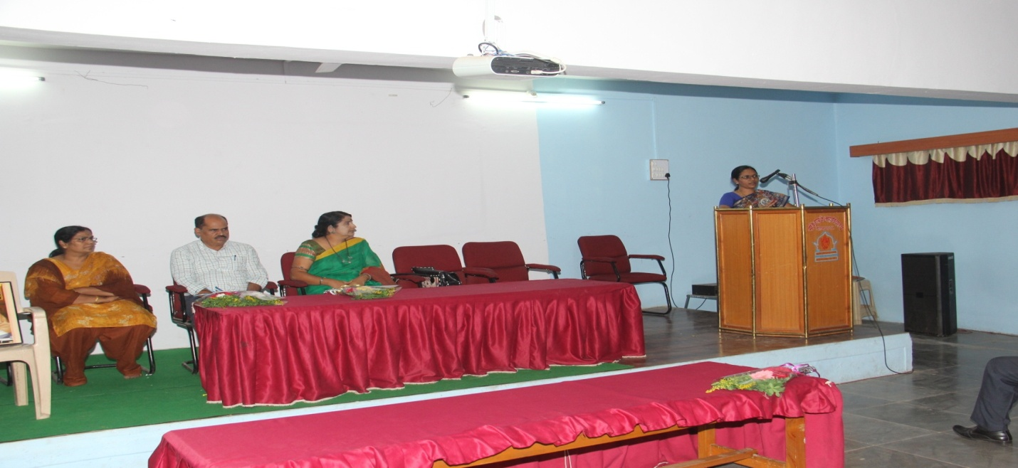
Dr. P.R. Maheshmalkar delivered an introductory speech
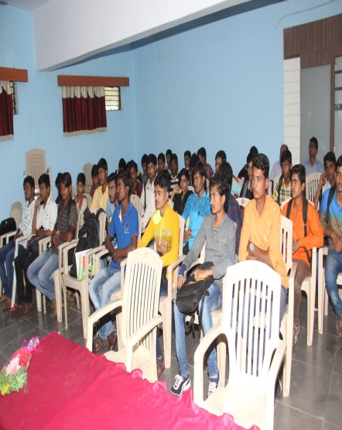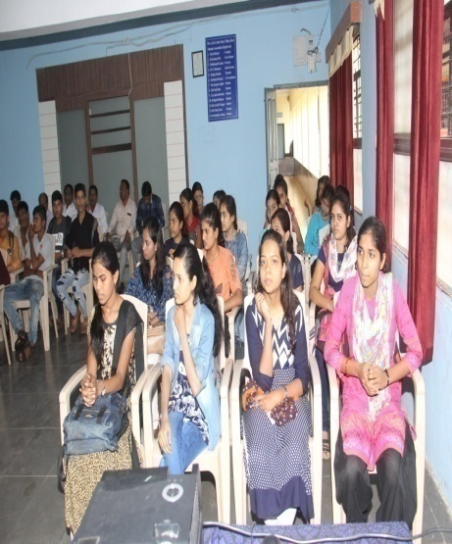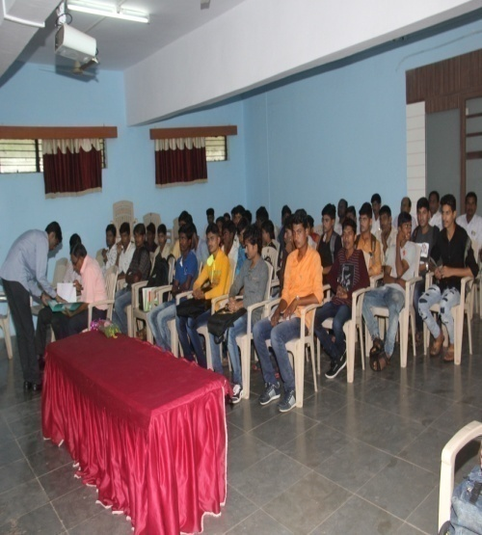
Active Participation of Students and Staff during elocution competition
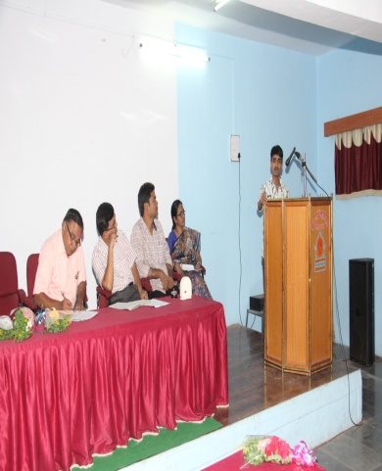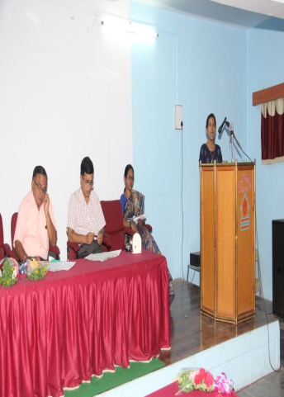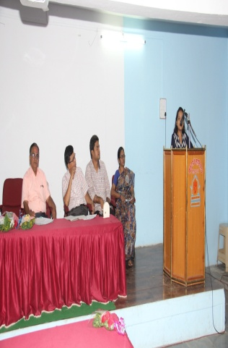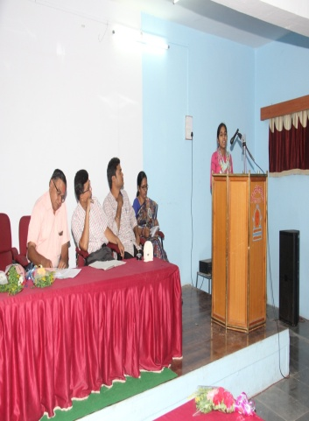The judge of the competition Prof. Shastri S.G., Prof. Malode S.S, Prof Jadhav A.D. & Dr. Pradnya Maheshmalkar, were present during elocution competition and the participants

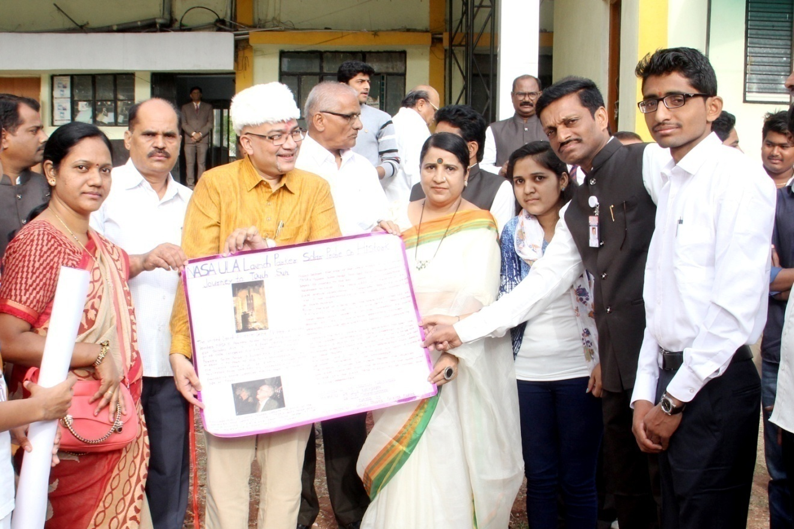
Students of Department Publishing the wall paper by the Auspicious hands of Chief Guest and respected Guests
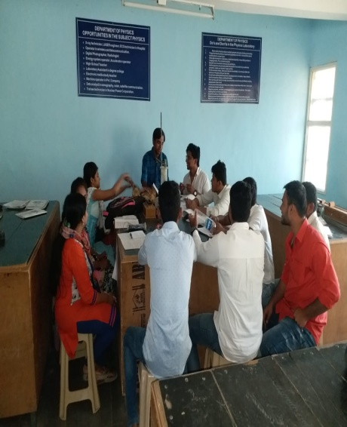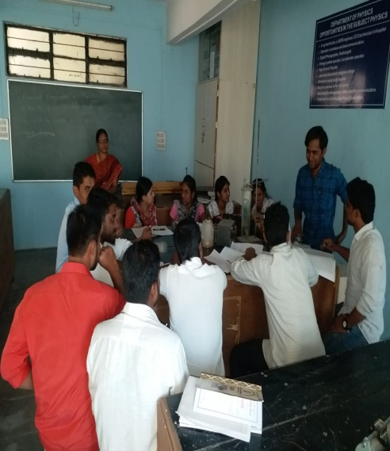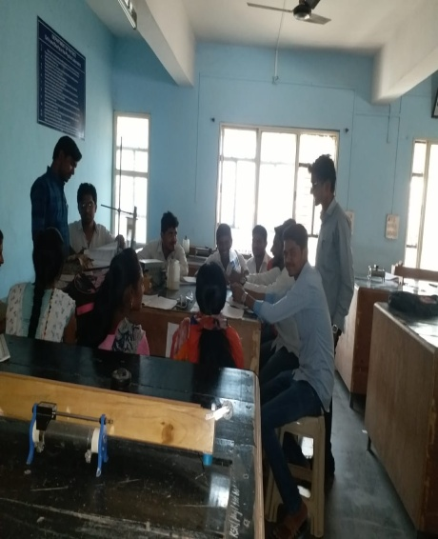
Students of Department Participated in the Group Discussion

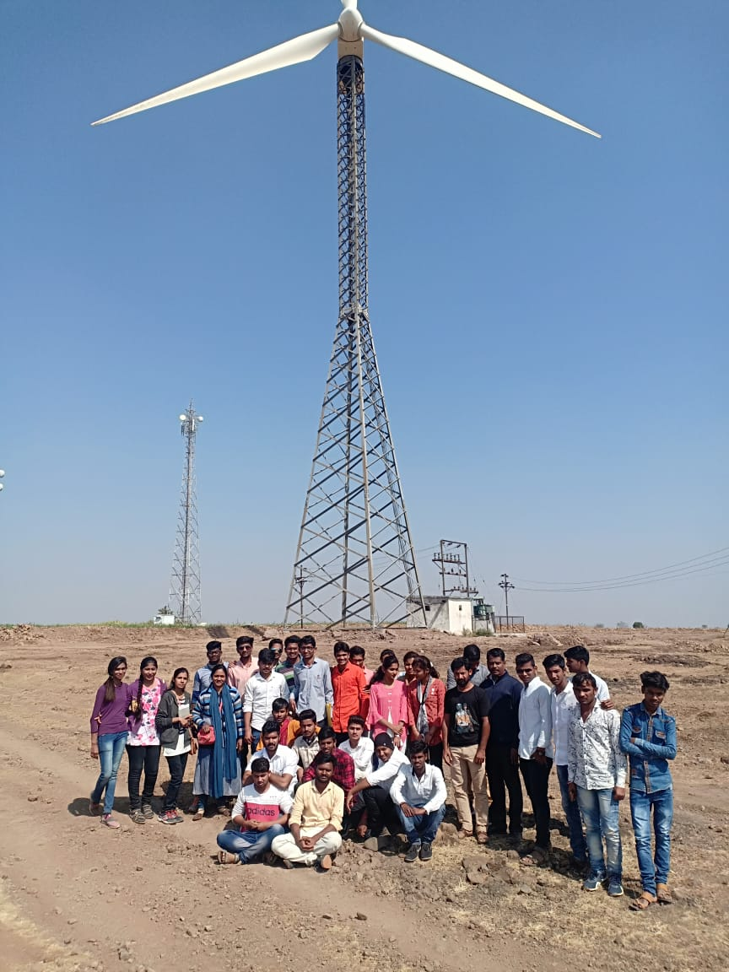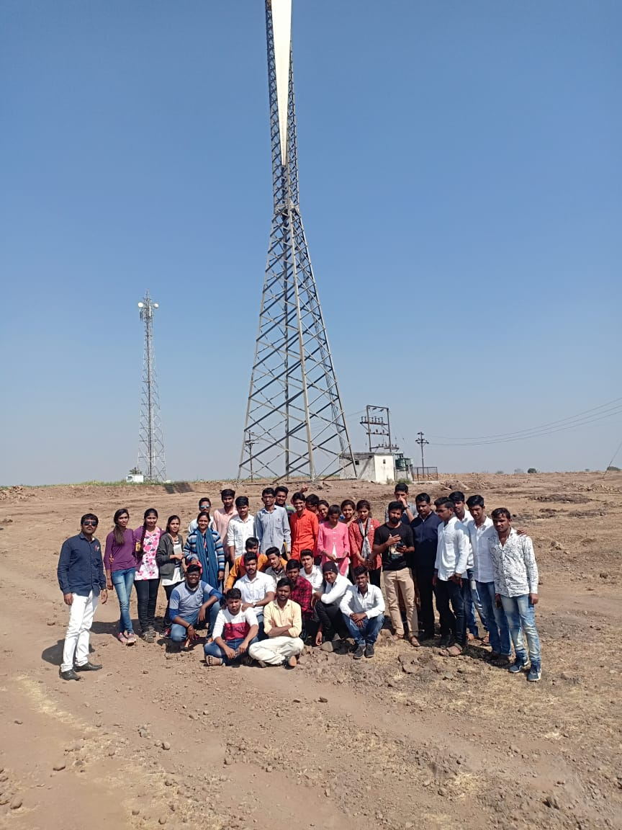
Wind energy project, sautada Ta. Patoda Dist. Beed and Participated Students of Department
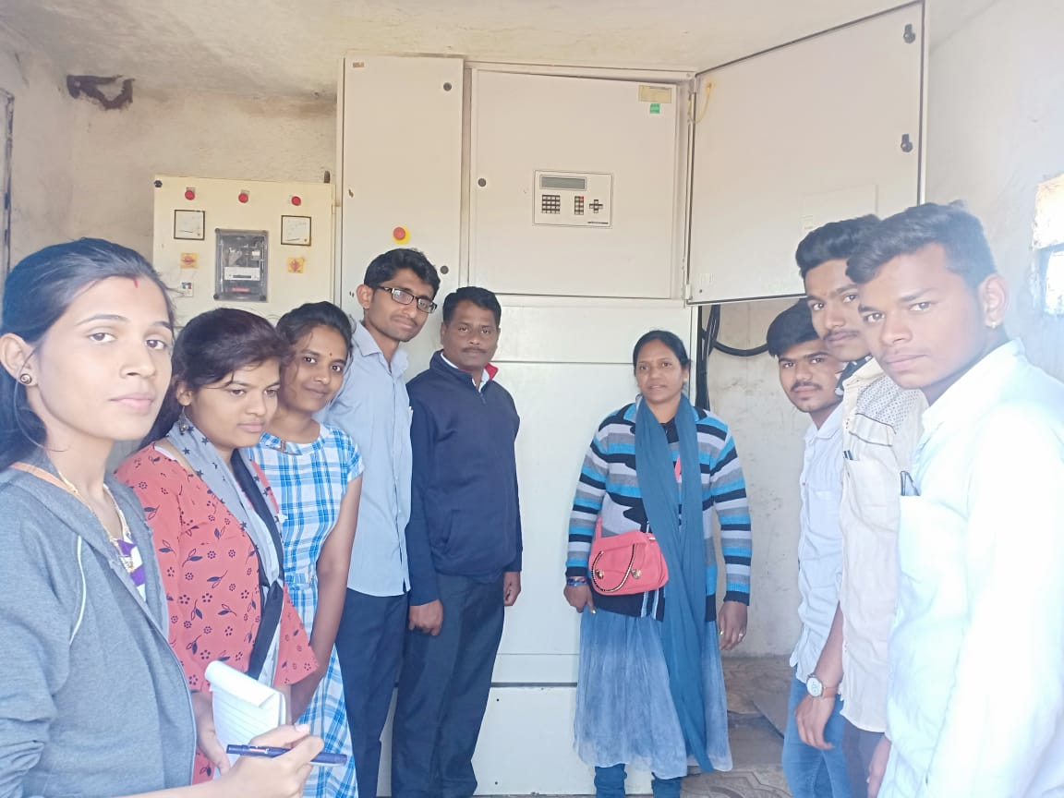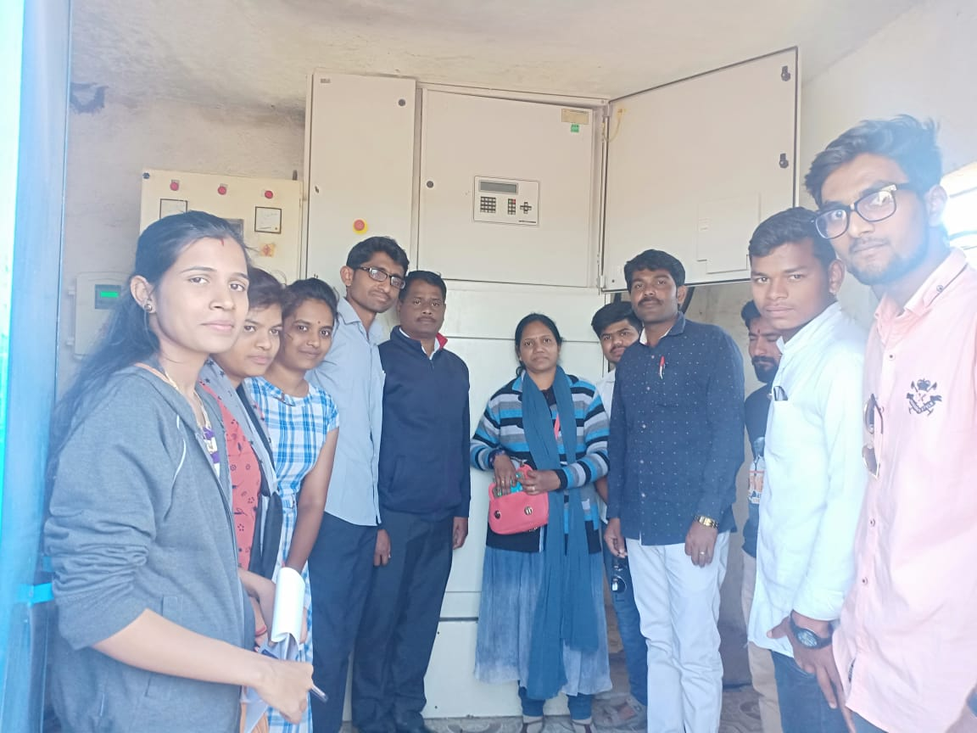
The Students collected the information about the generation of electricity and propagation of it.
Department of Physics was organized an educational Tour at Wind energy project, sautada Ta. Patoda Dist. Beed. 30 Students of B. Sc I, II and III year were actively participated in this educational Tour. The Students had got the information about the generation of electricity and propagation of it. They are also familiar with different energy projects in Maharashtra. The detailed information was given by the technician Mr. Tekale. The Tour Was Informative for Students. Dr. Deepa Kshirsagar, Principal, Vice Principal Dr. Abasaheb Hange Dr. Shivanand Kshirsagar Vice Principal and HOD of the Dept. Guided for the success of this Tour. Dr. Pradnya Mahesmalkar, Prof. Gajanan Shreemangale, Mathematics Dept, Prof Rupesh kokate , Prof. Anand Shingare worked hard to make the tour successful.

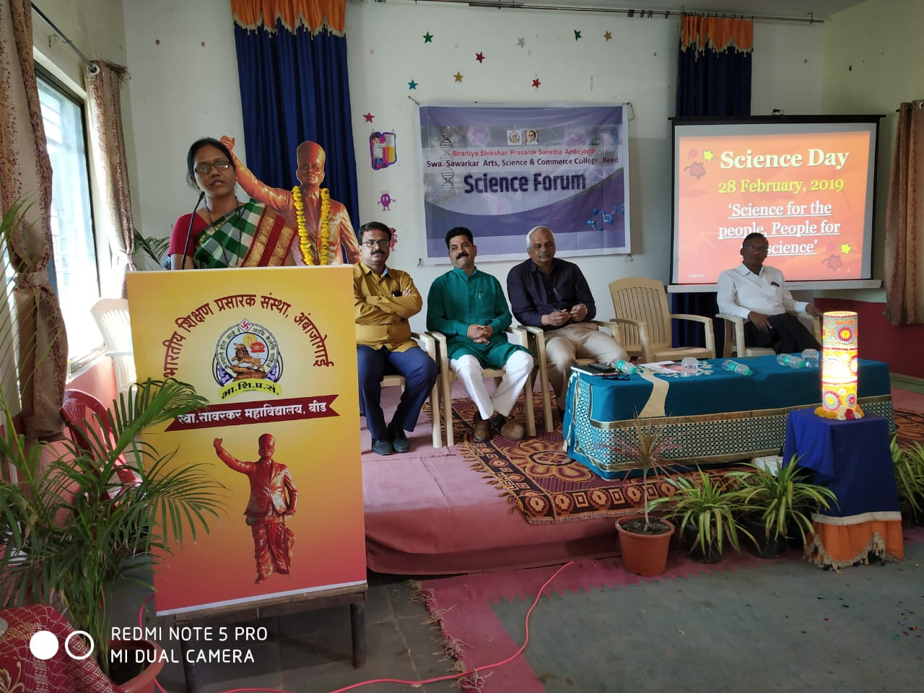
Dr. Maheshmalkar P.R. Delivering a Lecture on C.V Raman on the occasion of National Science day at Swa. Sawarkar college, Beed, as a Chief Guest and respected Dias
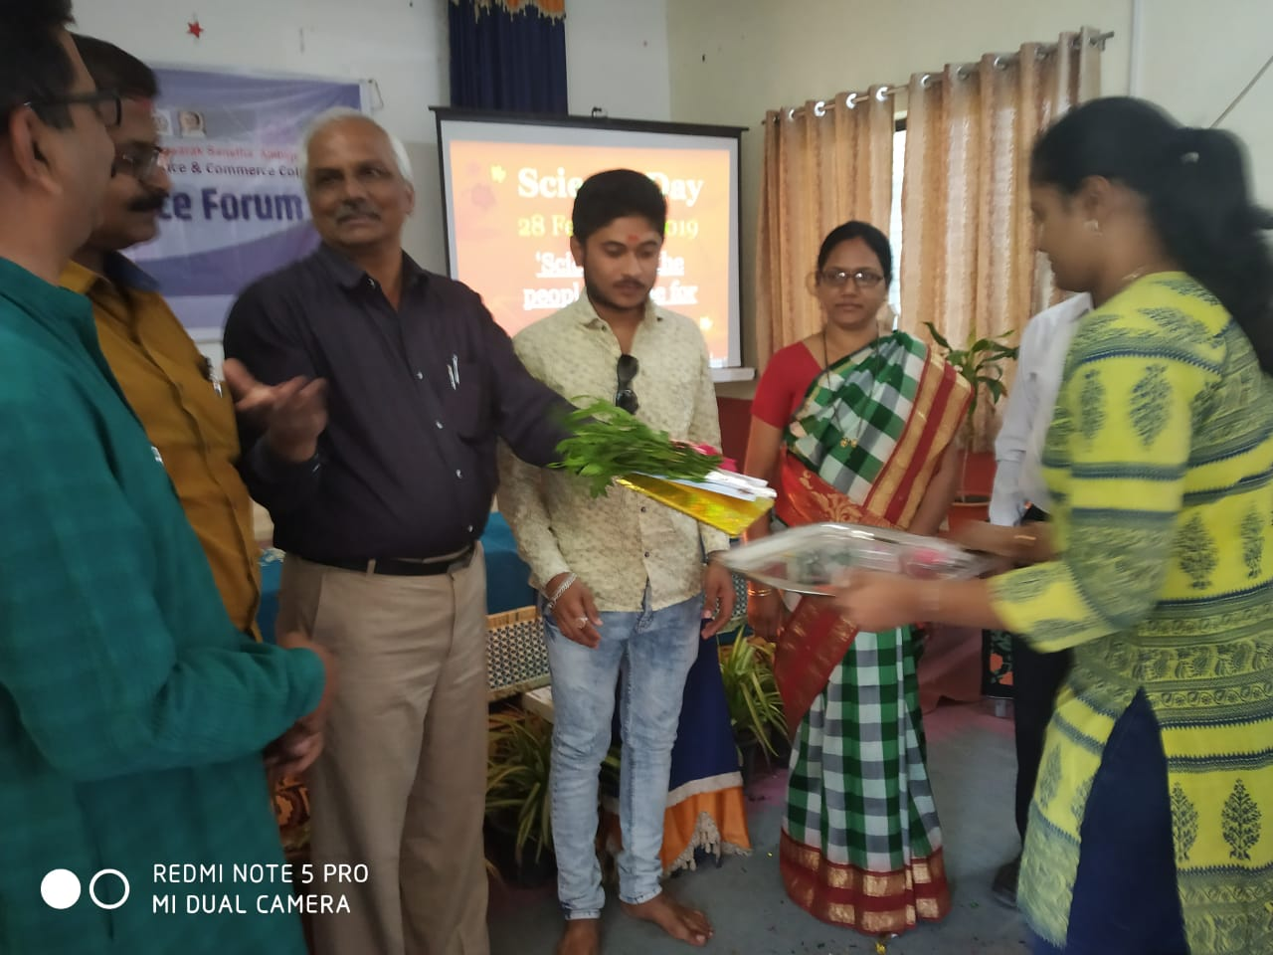
Dr. Maheshmalkar P.R. Distributed prizes to the winners on the occasion of National Science day at Swa. Sawarkar college, Beed, as a Chief Guest and respected Dias

