Mrs. K.S.K.College,Beed
DEPARTMENT OF PHYSICS
Photo gallery(2019-2020)

Name of Event | Rajiv Gandhi Energy Conservation Day
Organised by | Department of Physics
Date and Time of Event | 14thAugust, 2019, at 10.50 am to 11.40 am, Essay writing Competition, a Guest Lecture on “Solar Energy”, Dated on 20 August, 2019and Prize Distribution
Details of Activity | On the occasion of Rajiv Gandhi Akshy Urja Din,to create awareness about the energy conservation, to Popularise benefits and uses of renewable energy devices and systems and also memorialize the birth anniversary of the late Prime Minister of India, Rajivaji Gandhi.  On 14thAugust, 2019, Essay writing Competition was organized by Department, on the occasion of Rajiv Gandhi Energy Conservation day.  Dr. Swati Kulkarni, HOD, Dept. of physics, Swa. Sawarkar Mahavidyalaya, Beed, delivered a Lecture on “Solar Energy”, Dated on 20 August, 2019.
Chief Organiser | Principal Dr. Deepa Kshirsagar.
Organiser | vice Principal and Head of the Department Dr. Shivanand Kshirsagar
Other Faculty as Supervisor | Dr. Pradnya Maheshmalkar, Mr. Rupesh Kokate
No. of Participated Students | 20 Students were participated in the competition, 56 students of 11th, 12 th and B.sc. I, II, III year were present for the guest Lecture and Prize Distribution programme.

Summary of the Event-
Rajiv Gandhi Energy Conservation Day
on the occasion of Rajiv Gandhi Akshay Urja din, a Essay Writing competition was organized by department of physics, On 14 August 2019 at 10.50 am to 11.40 am in Hall No 50. The main aim of the competition was to create awareness about Saving & Conservation of energy.This is a campaign in terms of energy development.
The subjects for this competition were
1. In Future, challenges of energy in front of India and it’s Solutions
2. Different Methods of Generation of Energy
20 Students were participated in the competition. Their Essays were assessed by Prof. Raut S.S, Jr. Lecture of department of physics. From all participants, 3 participants were given awards by the hands of respected Dias. In this Competition, Ugale Prashant Shivnath, B.Sc.II stood Ist, Shinde Suhas Bapusaheb,11th (science) stood 2 ^{nd}and Sarwade Vishwajit Sanjaykumar 11 th (Arts) stood 3 ^{rd}.
On 20 August,2019,Rajiv Gandhi Energy Conservation day , the prize distribution Programme of essay writing Competition as well as a Lecture entitled, “Solar Energy” of Dr. Swati Kulkarni, Head, Dept. of Physics, Swa. Sawarkar College Beed was organized by dept.Dr. Deepa Kshirsagar,Principal, Dr. S.V. kshirsagar, vice Principal and head of the department of physics guided for Competition. Vice Principal Dr. A.S. Hange was the president of this function, Prof.Sayyad Lala, P.G. Director, Dr. Rekha Gulve, presided over the function.
Dr. P.R. Maheshmalkar delivered an introductory speech. She declared the picture of departmental activities & Aim behind the competition through her speech. Also This programmes was anchored by Dr. P.R. Maheshmalkar & Vote of thanks was proposed by Prof. Kokate R.56students of 11th, 12 th and B.sc. I, II, III year were present for the guest Lecture and Prize Distribution programme. For completion of this programme,efforts are made by Prof. A.D. Jadhav, Shri Gange Anurath and Shri. .YAdhav G.B.

Photogallery
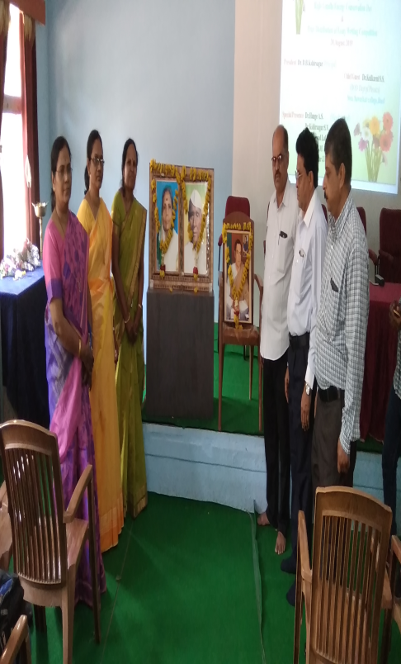
Respected GuestDr. Swati Kulkarni,on the occasion of Rajiv Gandhi Energy Conservation day(14thAugust, 2019)
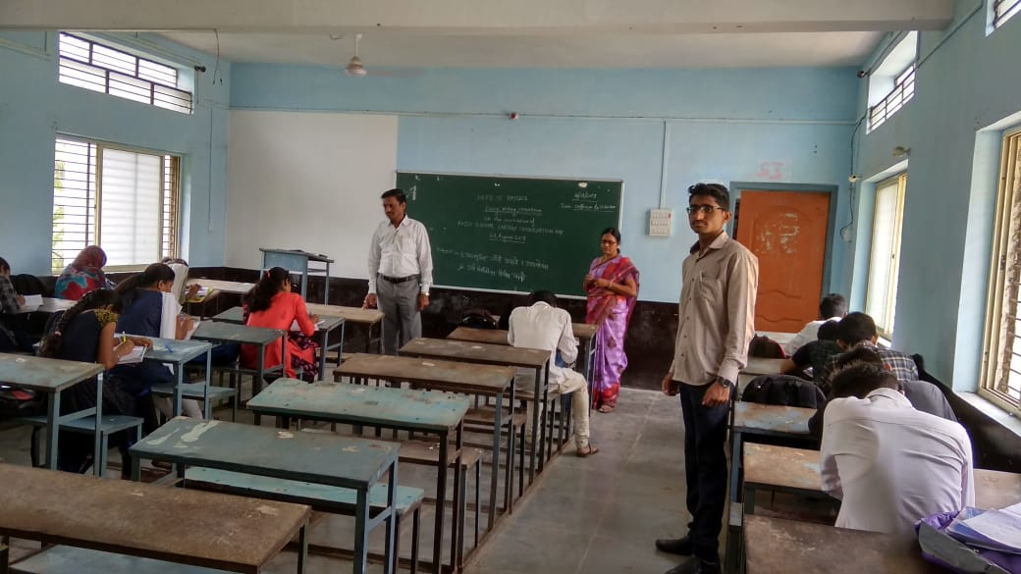
Essay writing Competition was organized by Department, Hon’ble Vice Principal and HOD Dr. S.V.Kshirsagar and Faculties

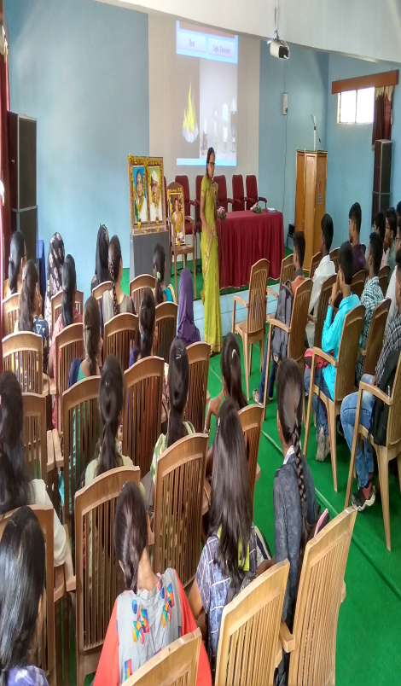
Dr. Swati Kulkarni,delivering a Lecture on “Solar Energy”
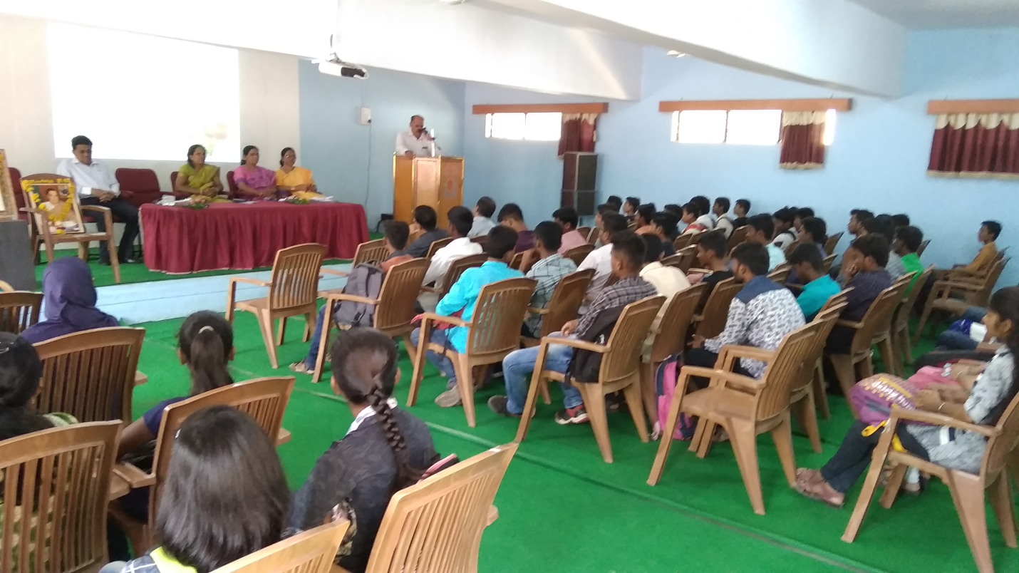
Hon’ble Vice Principal, Dr. A.S. Hange Expressing the Presidential Remark and Respected dias

Name of Event | Guest lecture (Online mode)
Organised by | Department of Physics
Date and Time of Event | on date 21 January 2020.
Details of Activity | a Lecture entitled “Birth of Universe”
Chief Organiser | Principal Dr. Deepa Kshirsagar.
Organizer | Vice Principal and head of the Department Dr. Shivanand Kshirsagar
Other Faculty as Supervisor | Dr. Pradnya Maheshmalkar
No. of Participated Students | 47 students of B. Sc I, II and III years

Photogallery

- Mr. Tate B.T. Balbhim College, Beed, Delivered a Lecture entitled “Birth of Universe” on date 21 January 2020.

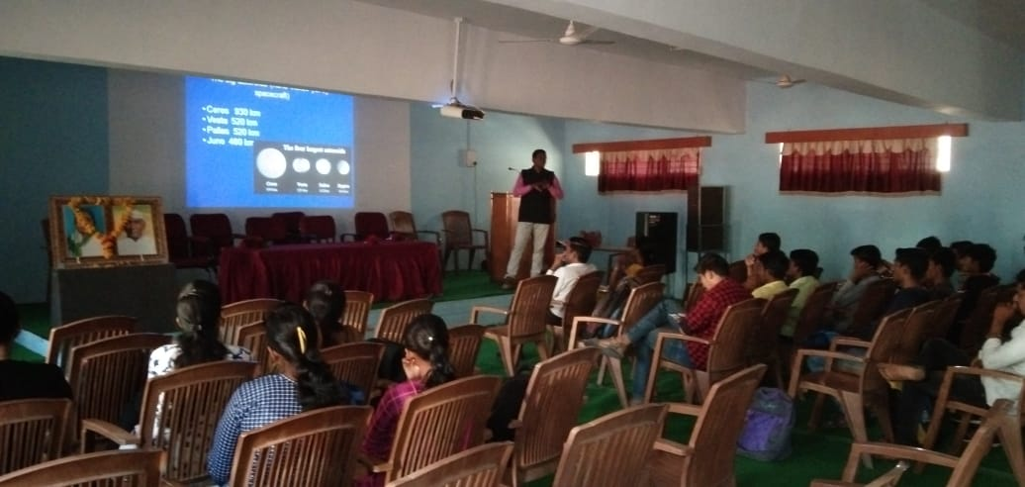
Mr. Tate B.T. delivering a Lecture on “Birth of Universe”
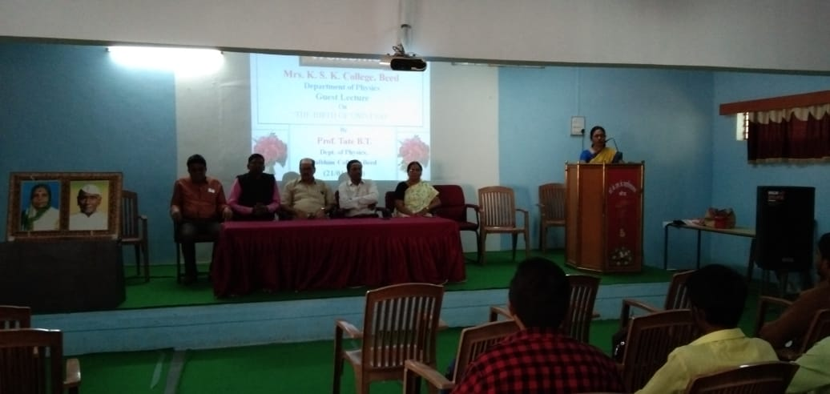
Respected Guest on the occasion of, guest lecture of Mr.Tate B.T.

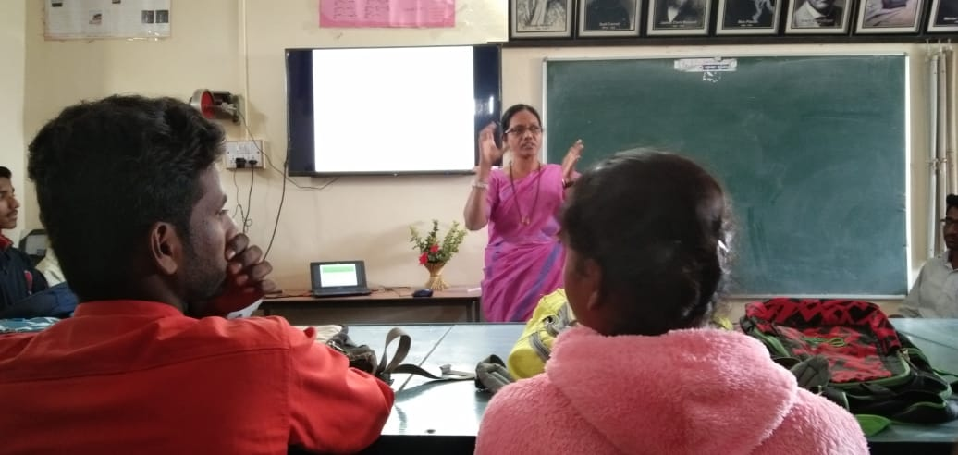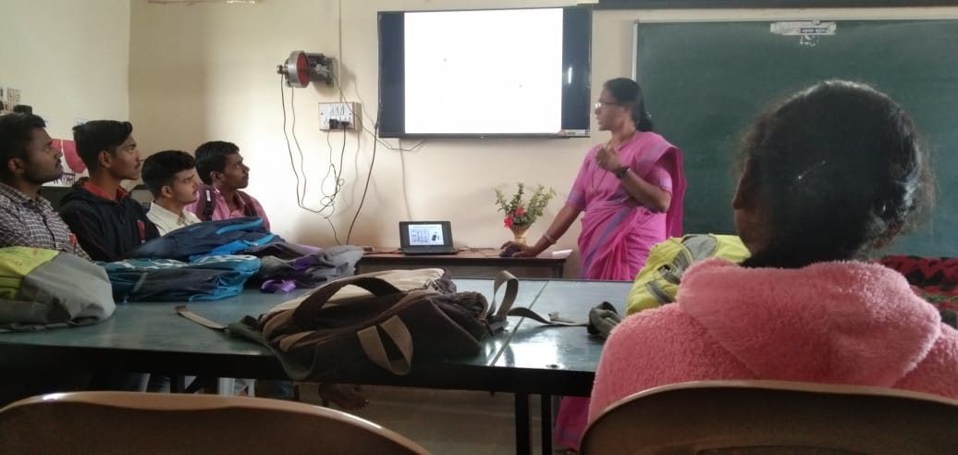
Dr. Maheshmalkar P.R, delivering a Lecture on “Raman Effect” at Swa. Sawarkar Mahavidyalaya, Beed,

Name of Event | College College Interaction
Organised by | Department of Physics
Date and Time of Event
Details of Activity
Chief Organiser | Principal Dr. Deepa Kshirsagar.
Organizer | Vice Principal and head of the Department Dr. Shivanand Kshirsagar
Other Faculty as Supervisor | Dr. Pradnya Maheshmalkar
No. of Participated Students | 21 students of B. Sc I, II and III years

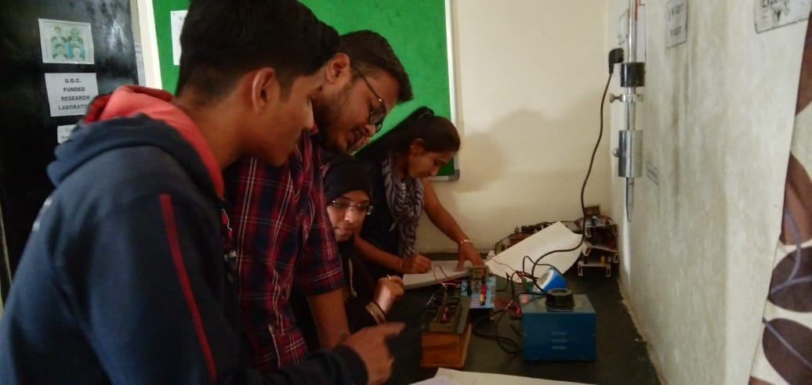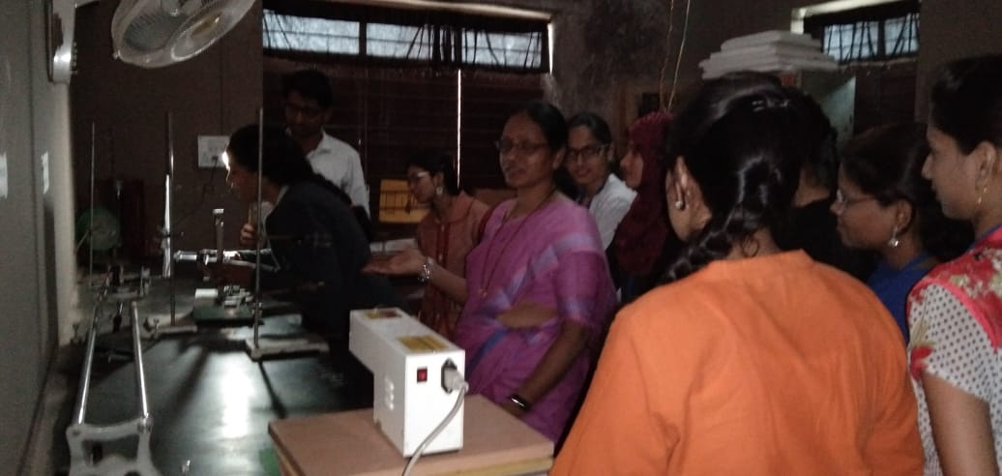
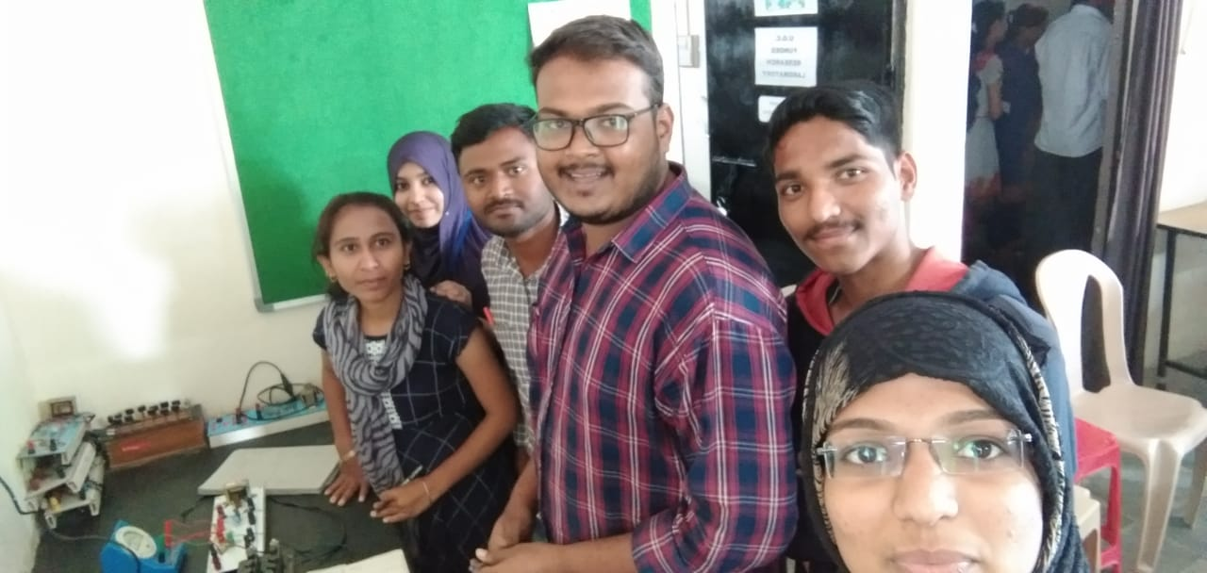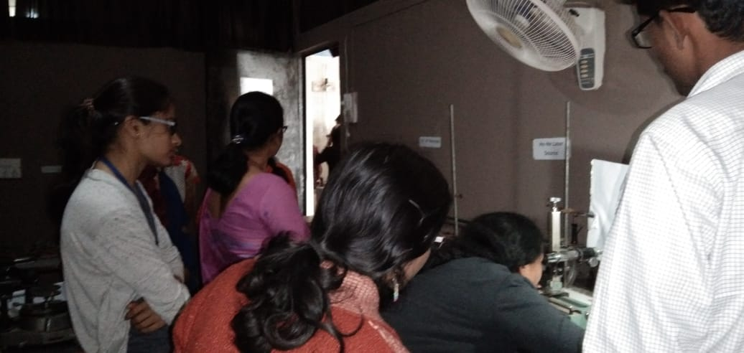
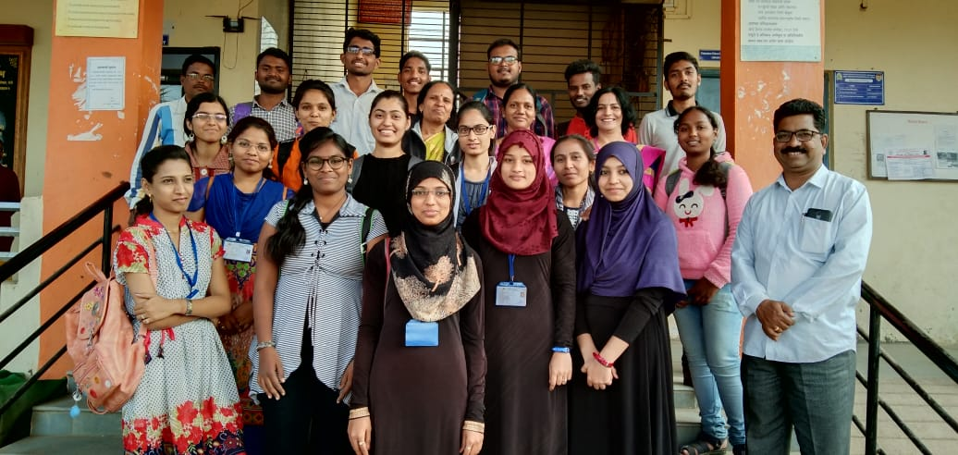
Through College -College Interaction, Students of B.Sc. III ,visited the physics laboratories of Swa. Sawarkar Mahavidyalaya, Beed,

Name of Event | School College Interaction
Organised by | Department of Physics
Date and Time of Event
Details of Activity | Through School College Interaction the students of Shri. Shivaji Vidyalaya, Beed, visited our laboratories and we Introduced and demonstrated various Experiments to them
Chief Organiser | Principal Dr. Deepa Kshirsagar.
Organizer | Vice Principal and head of the Department Dr. Shivanand Kshirsagar
Other Faculty as Supervisor | Dr. Pradnya Maheshmalkar
No. of Participated Students | 77 students of B. Sc I, II and III years

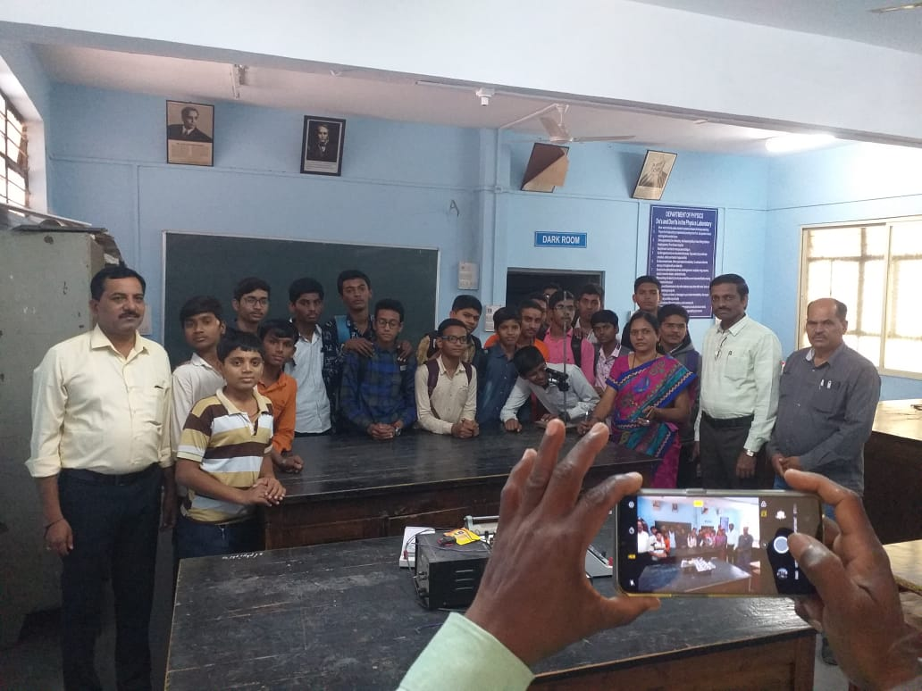
Through, School College Interaction the students of Shri. Shivaji Vidyalaya, Beed, visited our laboratories and we Introduced and demonstrated various Experiments to them.

Name of Event | Educational tour
Organised by | Department of Physics
Date and Time of Event | On 7 th February, 2020,
Details of Activity | at National Science Park, Pimpri Chinchwad, Empress Garden and Rajiv Gandhi Zoo Park, Pune.  different energy projects in Beed,Maharashtra.
Chief Organiser | Principal Dr. Deepa Kshirsagar,.
Organiser | Vice Principal and head of the Department Dr. Shivanand Kshirsagar
Other Faculty as Supervisor | Dr. Pradnya Maheshmalkar, Mr. Rupesh Kokate
No. of Participated Students | 31 Students of B. Sc I, II and III year

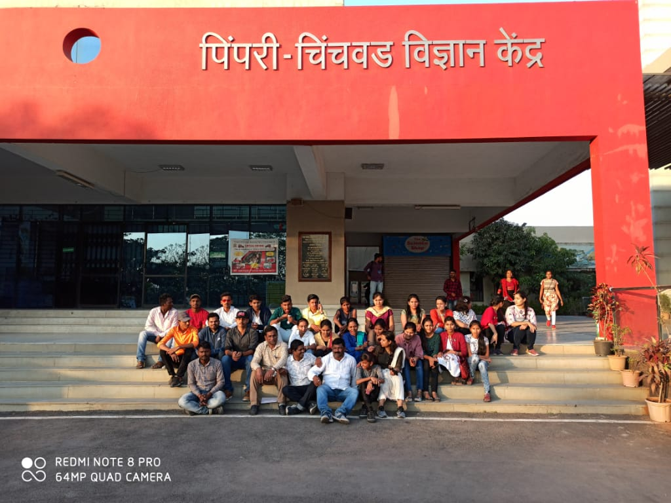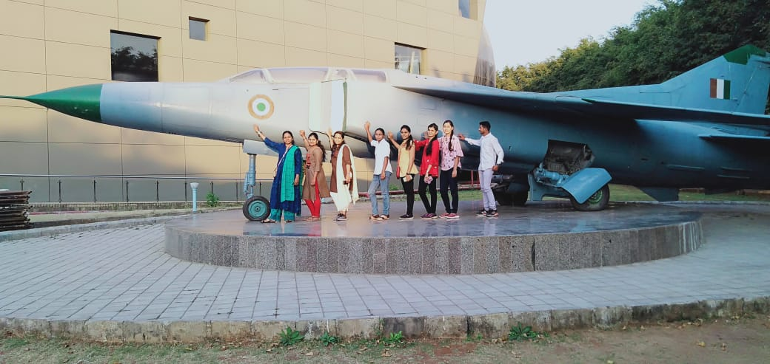
Department was organized the educational Tour at National Science Park, Pimpri Chinchwad,

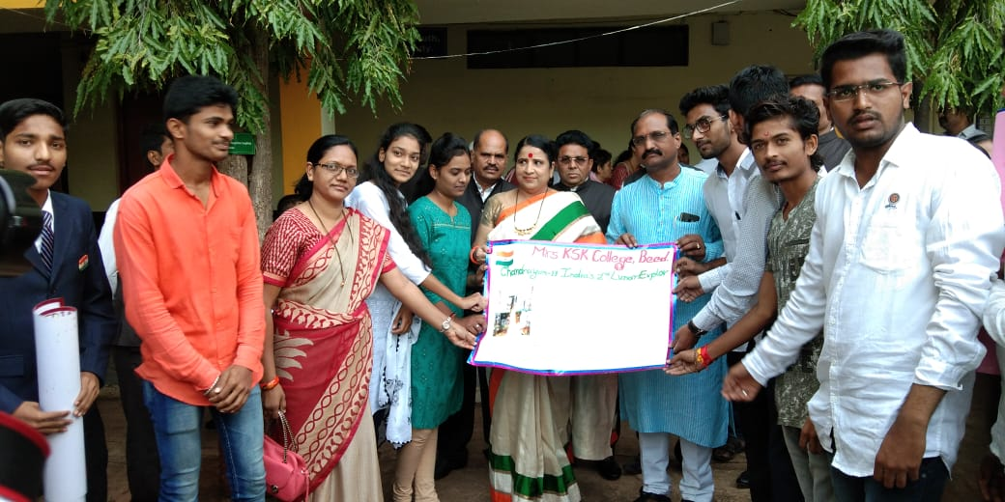
Wall paper Publicationby Hon’ble guest and Principal Dr. Deepatai Kshirsagar

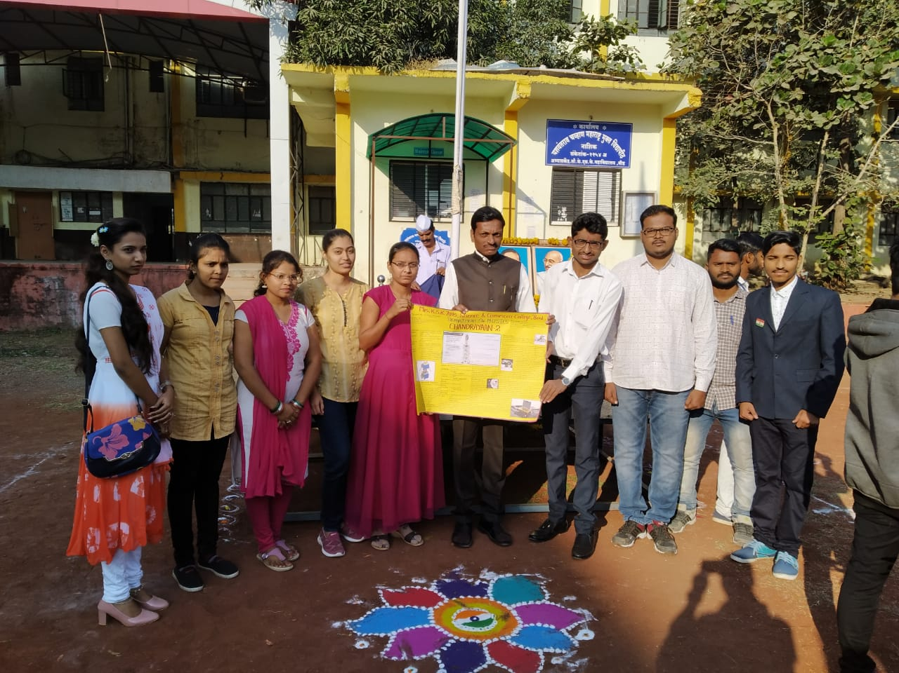
Departmental Students Published Wall papers on 15 th August 2019 entitled “ Chandrayaan Mohim” and 26 Jan. 2020 “Chandrayaan II”

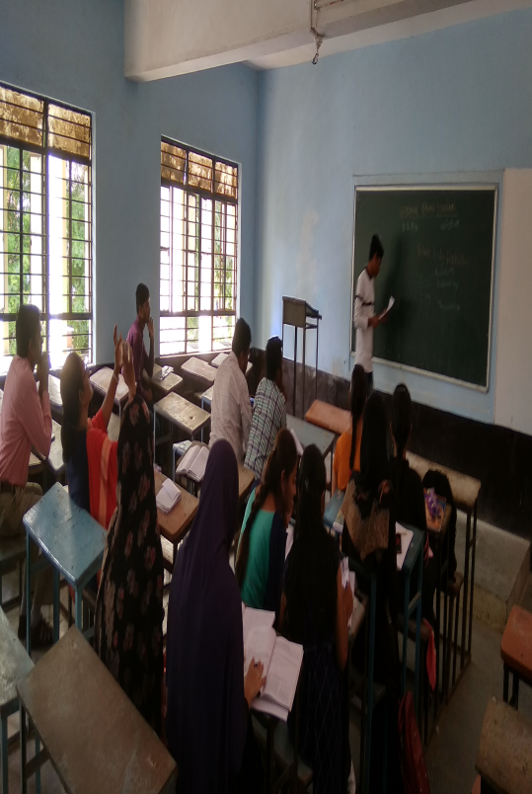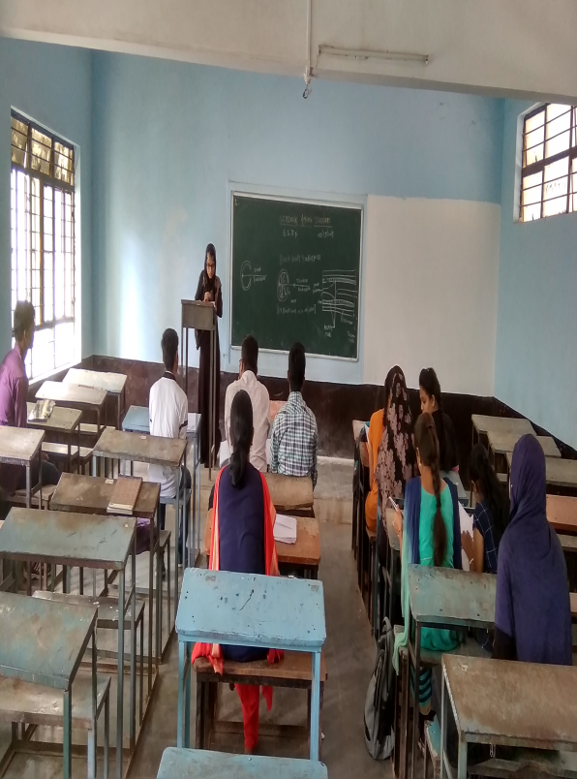
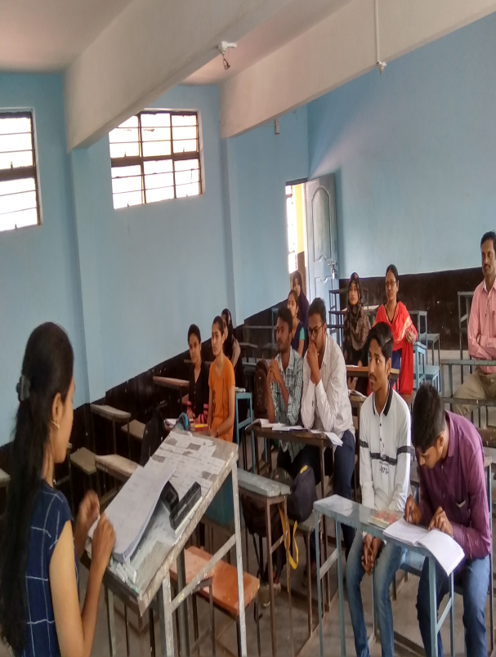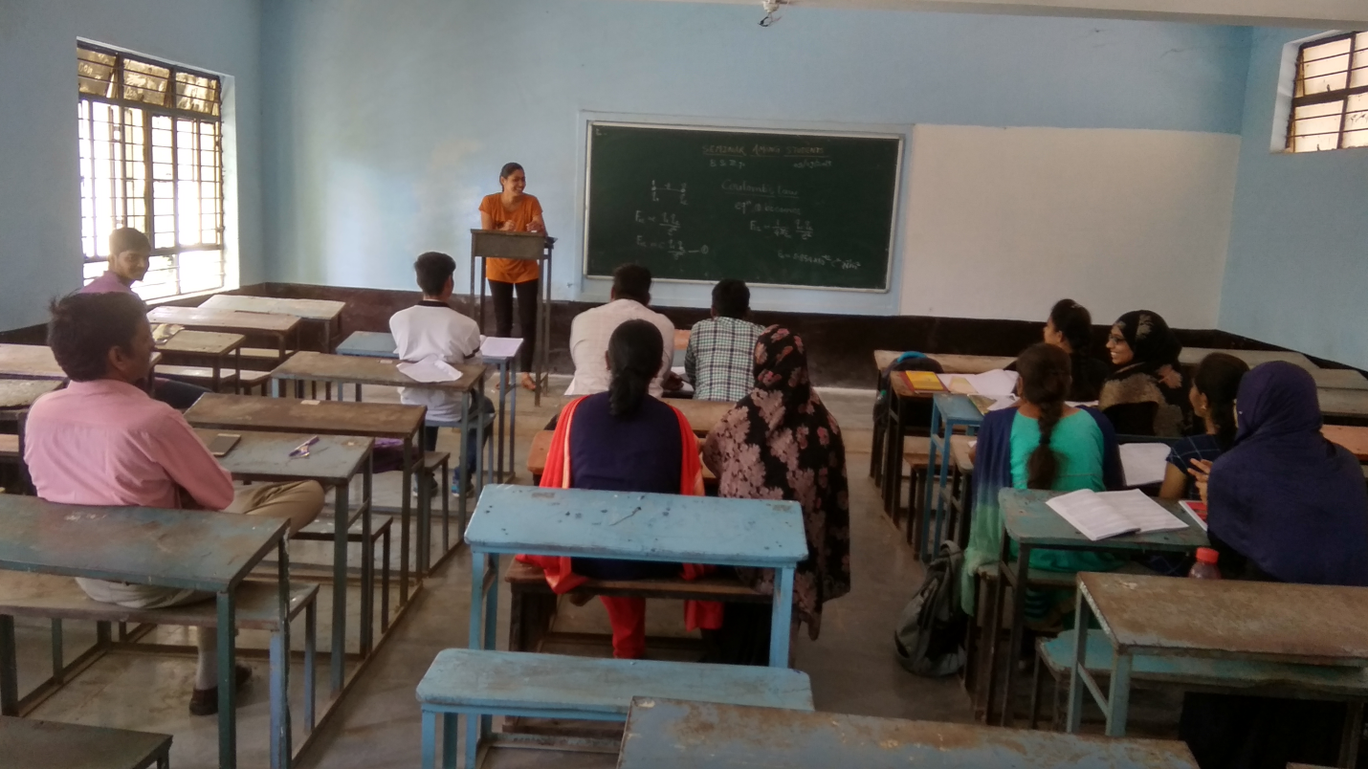
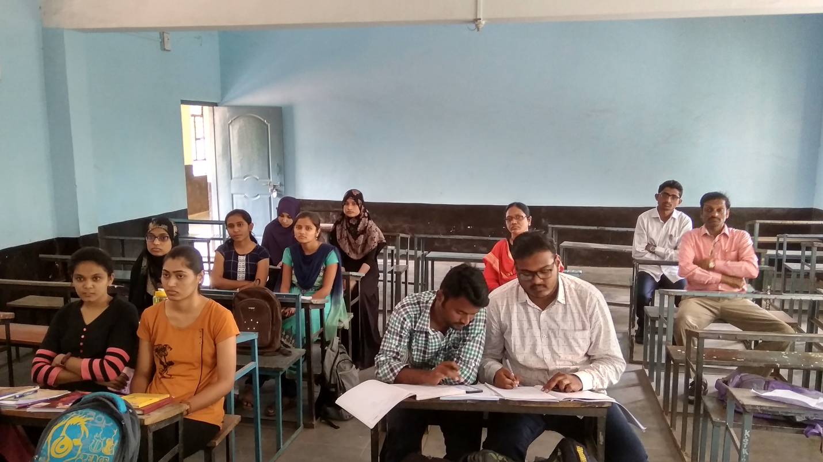
Department conducted seminars and Group Discussions among Students.

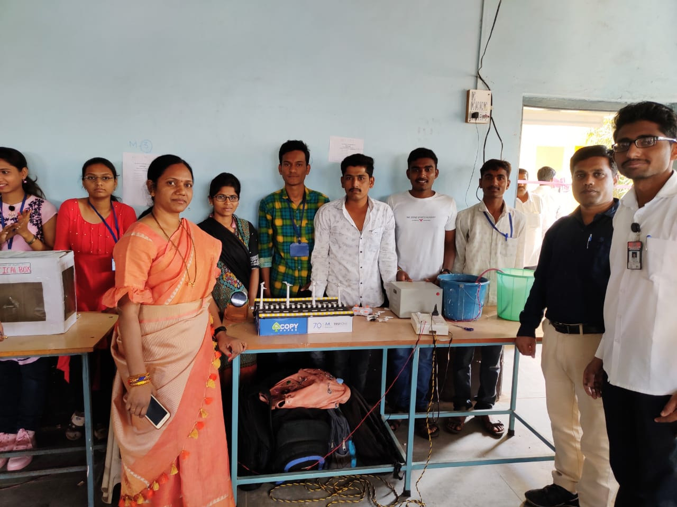

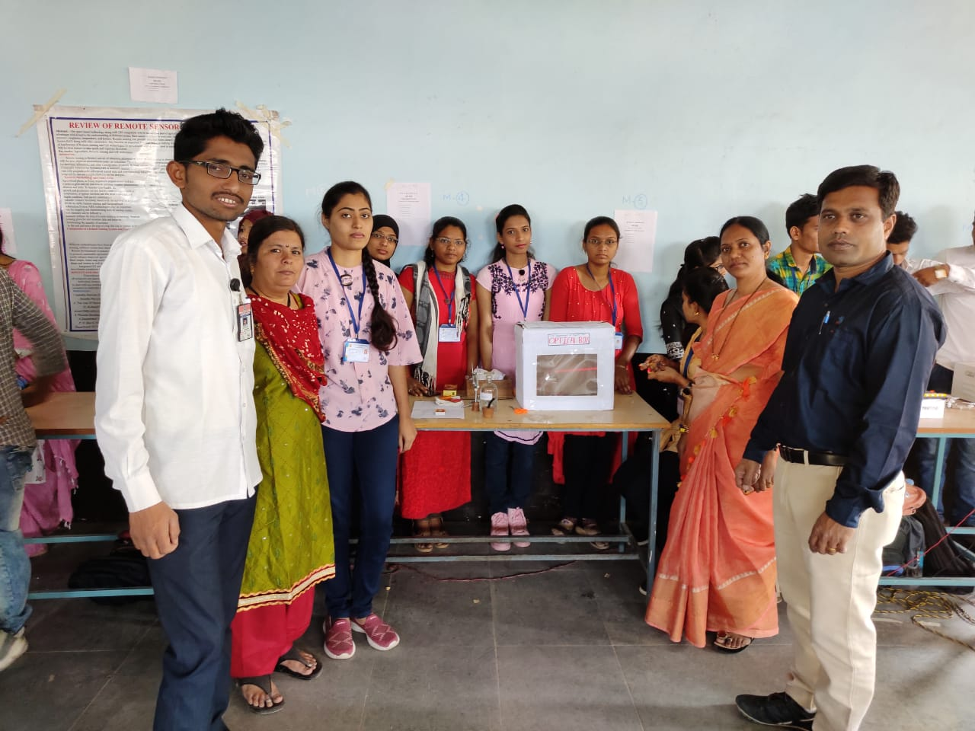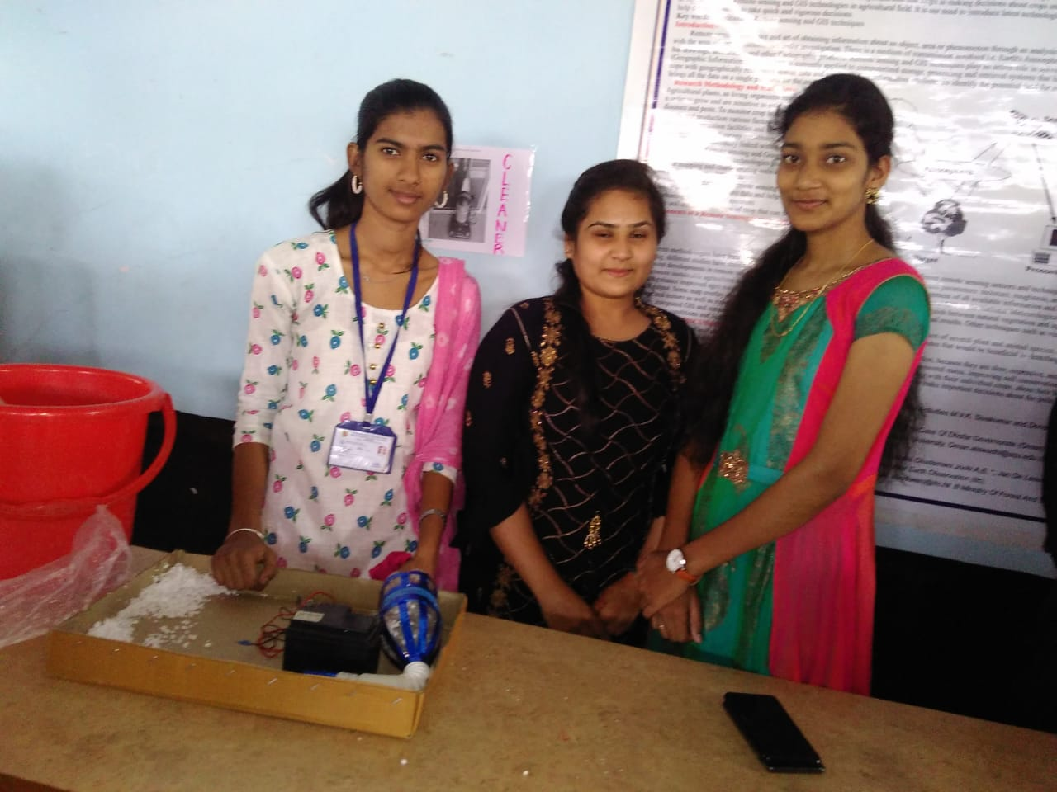
Students performing and demonstrated the Experiments, in the science exhibition on the occasion of Annual college gathering.

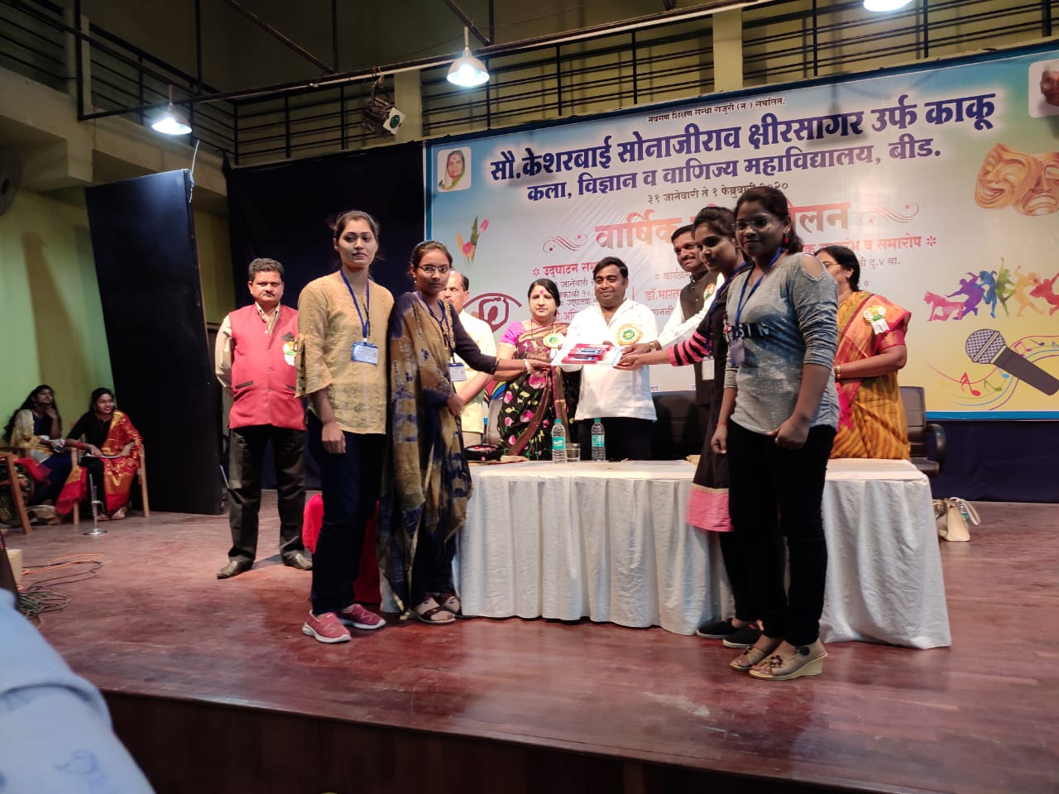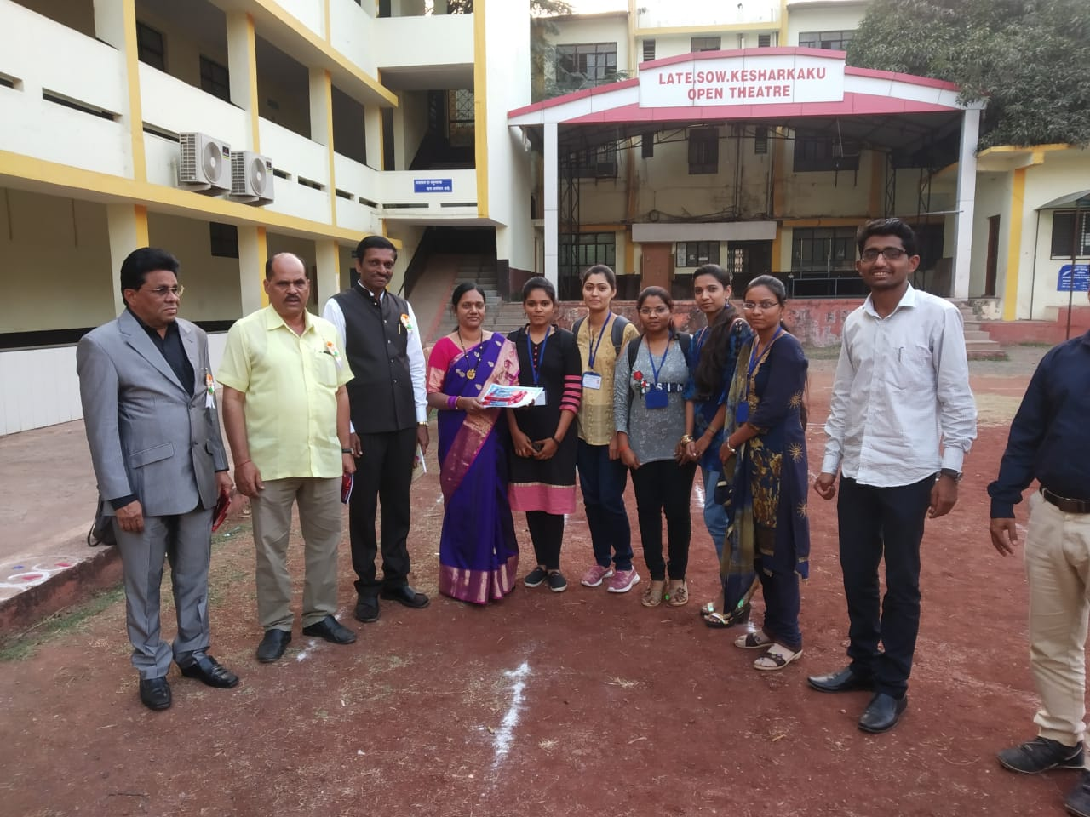
In the science exhibition on the occasion of Annual college gathering students won the Second Prize for Optical Box Experiment.

