DEPARTMENT OF PHYSICS
(2020-2021)
Annual Report
Teaching and other activities are held in accordance with the schedule prescribed by Dr. Babasaheb Ambedkar Marathwada University, Aurangabad and College Administration. The activities run by the department during, 2020-2021 academic year are as follows
- The online activities were performed as a work from home suggested by UGC as well as Dr. Babasaheb Ambedkar Marathwada University, Aurangabad
Dr. Maheshmalkar Pradnya Ramdas, Specially designed for B.Sc III year Physics Students, named as “Test for B.Sc. III Yr. Physics Students” on 1st and 4th May, 2020 with the links below
- https://docs.google.com/forms/d/e/1FAIpQLScGmhljB78rXUzih2lDU3Vls6T-Uao0CFmJ_BZYk_8bmPlnJg/viewform?usp=sf_link
- https://docs.google.com/forms/d/e/1FAIpQLSefg6lfD5TiWpUwmgbRPnengShsUFdgmNKmLNjK2T7uRwm0iw/viewform?usp=sf_link
Dr. Maheshmalkar Pradnya Ramdas, Specially designed for B.Sc Physics Students, named as “Test for Basic Physics” dated on 20 and 23 May, 2020 with the following links
- https://docs.google.com/forms/d/e/1FAIpQLSd9DFuxG5WIgVLz3vtqTczwecKvcaL1FfzUfFZH1DUHCPvI8g/viewform?usp=sf_link
https://docs.google.com/forms/d/e/1FAIpQLSfQ5ZZ2F8yuwqFIVW2gA5GbMCBZLb3qpLr65kxA1wqoNnuoDA/viewform?usp=sf_link

- Dept. organized a online guest lecture on the topic entitled “Crystallography” of the speaker, Dr. Kulkarni Rupali, Swa. Sawarkar Mahavidyalaya, Beed, on the date 18 January, 2021.
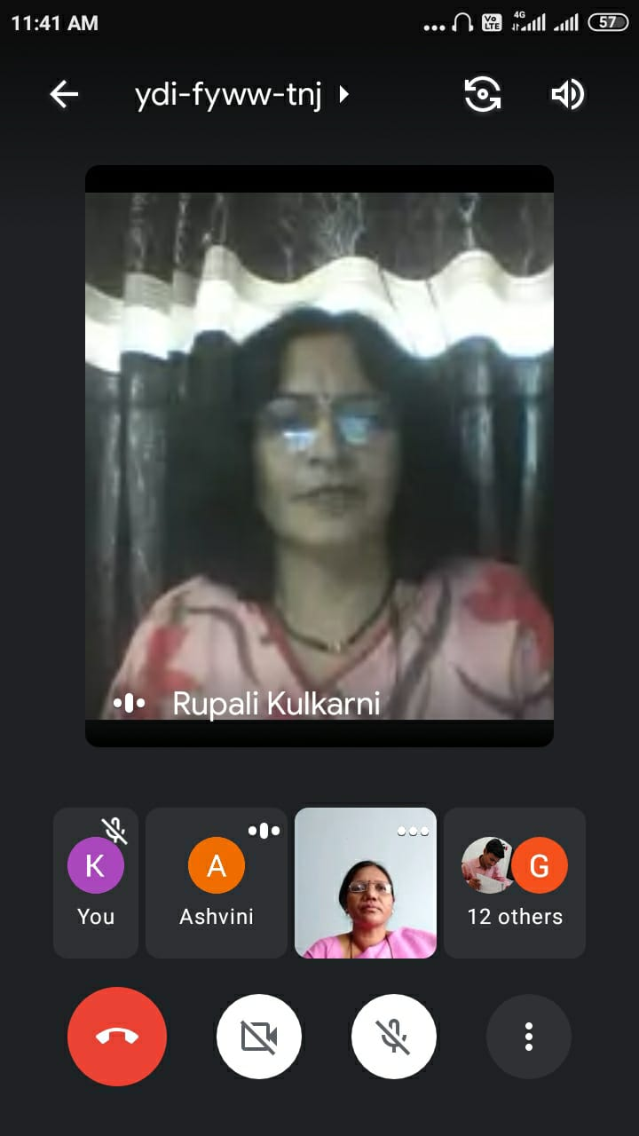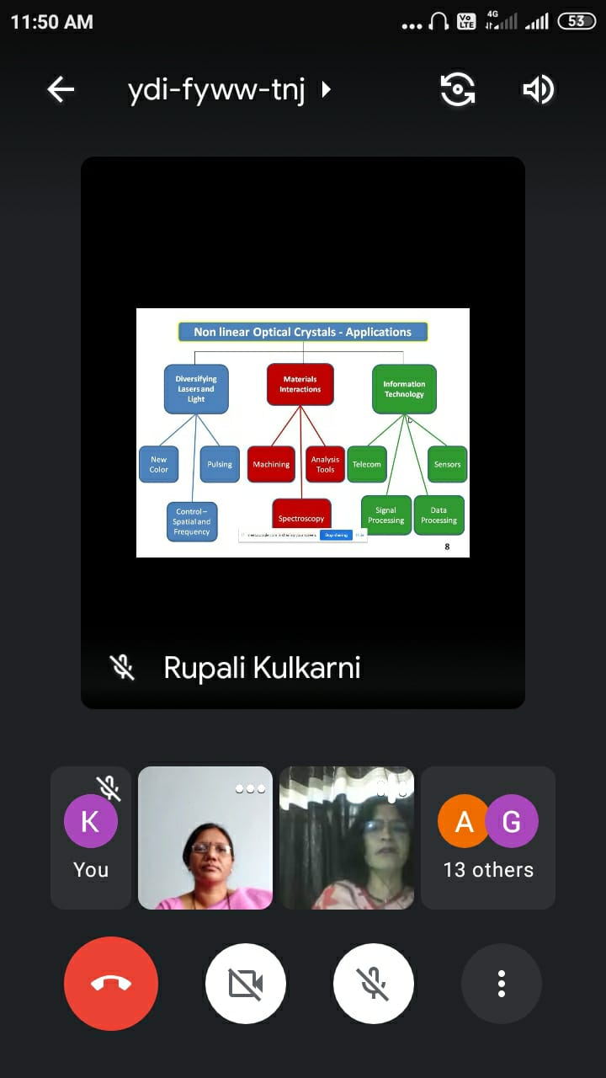
Dr. Rupali Kulkarni delivered online lecture and the faculty member Dr. Maheshmalkar P.R.
List of Participated Students-
Sr.No. | Name of Student
1 | Nikita Shelke
2 | Akshay Aute
3 | Ganesh Jarange
4 | Ganesh Patil
5 | Pratiksha Maske
6 | Pratiksha Tandale
7 | Ashwini Mane
8 | Jyotiram Shete
9 | Sajed Sayyad
10 | Sayali Misal
11 | Salonee Misal

- Departmental Students Published Wall paper on 26 Jan. 2021, entitled “Interaction of Covid 19 and Physics”.
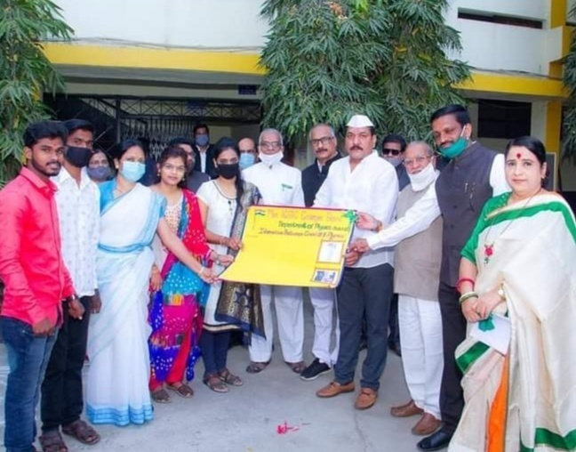Wall paper Publication entitled “Interaction of Covid 19 and Physics” by Hon’ble guest, Principal Dr. Deepatai Kshirsagar, and Vice principal as well as HOD, Dr. S. V. Kshirsagar, on 26 Jan. 2021.
List of Participated Students-
Sr.No. | Name of Student
1 | Kshirsagar Rutuja
2 | Todekar Sonali
3 | Dolas Kiran
4 | Pavse Mahadev

- On the occasion of national science day Department organized online Guest Lecture dated on 1 March, 2021 at 10.30 to 11.30 am of Dr. Hussaini S.S, Milliya College, Beed, entitled “Career after B.Sc. Physics” For B.Sc. Students. 17 students were actively participated.
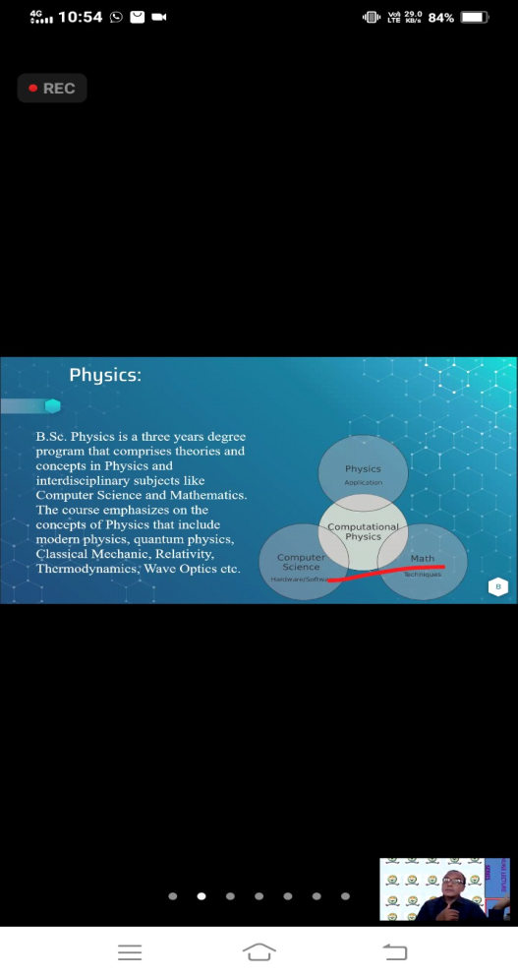
Dr. Hussaini S.S, conducted the online Guest Lecture dated on 1 March, 2021, entitled “Career after B.Sc. Physics”
List of Participated Students-
Sr.  No. | Name of Student
1 | Abhishek Munde
2 | Jyoti Bahir
3 | Nikita Shelke
4 | Nishigandha Gore
5 | Radika Pardeshi
6 | Pratiksha Waghmare
7 | Sajed Sayyad
8 | Swaranjali Kulkarni
9 | Akshay Aute
10 | Diksha Kale
11 | Pritee Ghodke
12 | Manoj Ghadge
13 | Sagar Kamble
14 | Shubham Bagade
15 | Sumit Naikwade
16 | Rutuja Jatal
17 | Sushant Rakte

- On the occasion of national science day, according to the theme (Women in Science), Dr. Maheshmalkar P.R. published a book entitled Classical and Quantum Mechanics for B.Sc. III, Sem V, and Paper XV, as per the syllabus of Dr. Babasaheb ambedkar Marathwada University, Aurangabad dated on 1 March, 2021
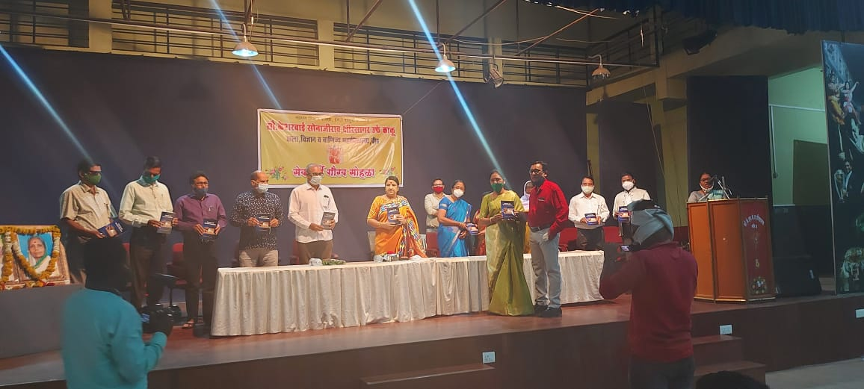
Book publication, of Dr. Maheshmalkar P.R. entitled “Classical and Quantum Mechanics” by the Auspicious hands of Hon’ble Principal, chief guests and Respected dais dated on 1 March, 2021 .
- In the golden Jubilee year of our College, On 20, August 2021wednesday on 4.00 pm to 5.30 pm, On the occasion of Rajiv Gandhi Akshy Urja Din, Department organized a guest Lecture of Hon’ble Dr. Chandrashekher M Kale, Vice Principal, Indraraj Art’s Comm. And Science College, Sillod, entitled “Future of Energy”.

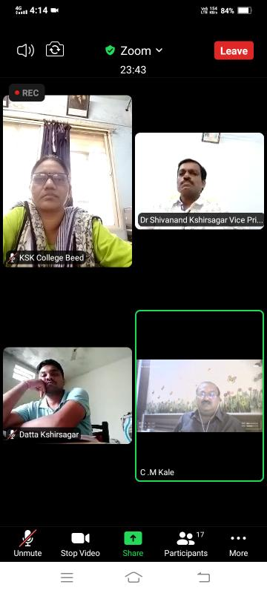
Hon’ble Dr. Kale C.M. delivering online Lecture entitled “Future of Energy” On 20, August 2021, On the occasion of Rajiv Gandhi Akshy Urja Din on this occasion Hon’ble Vice Principal , HOD Dr. S.V. Kshirsagar, Dr. P.R. Maheshmalkar and participants.
List of Participated Students-
Sr.No. | Name of Student
1 | Pratiksha Maske
2 | Dhananjay Shinde
3 | Umesh Todekar
4 | Datta Kshirsagar
5 | Komal Chandrasen
6 | PritiShelke
7 | Radhika Pardesi
8 | Pradeep Dake
9 | Pratiksha Tandale
10 | Sagar Kamble
11 | Sayali Khadakikar
12 | Shubham Badgade
13 | Sudarshan Gite
14 | Abhishek Munde
15 | Ashwini Mane
16 | Mahesh Khande
17 | Jyotiram Shete
18 | Shraddha Joshi

- Dr. Maheshmalkar P.R, Recited own poems in Poet conference (kavi sammelan) organized by Akashwani Centre, Beed in association with Dept. of Marathi of Mrs. K. S. K. College, Beed. Propagation of it was on Akashwani Centre, Beed, dated on 8 March 2021 at 5.00 pm to 6.00 pm.
- Dr. Kshirsagar S.V. delivered online talk on the subject “Role of teaching and nonteaching faculty in the process of NAAC”on 27, may 2021, at Sant Dnyaneshwar college, Soygaon, Dist. Aurangabad.
- Research and Professional Activities-
Details | Dr. Kshirsagar S.V. | Dr. Maheshmalkar P.R.
Book Published | 01 | 01
Chapters in Book published | 02 | 03
Paper published | 05 | 02
Conference /Seminar/Workshop Attended | 10 | 07
Courses | 1. Short term course at Dr. BAMU, Aurangabad(19-10-2020 to 24-10-2020) | -
 | 2. Jump Start course  (29-01-2021 to 31-01-2021) | Jump Start course  (29-01-2021 to 31-01-2021)

- Departmental students published wall paper on 15, august 2021, entitled “satellite remote sensing and covid-19”

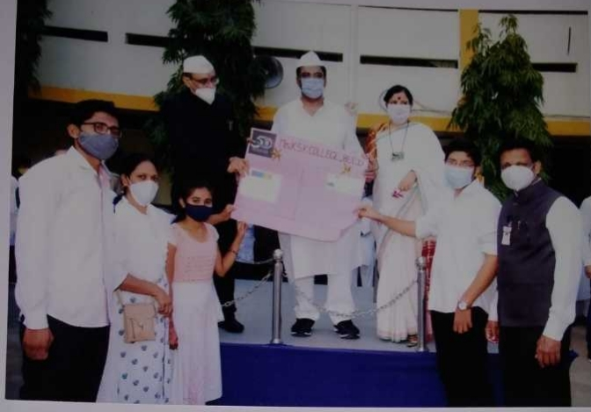
Wall Paper Publication on the occasion of 15, August 2021, entitled “satellite remote sensing and covid-19”, on this occasion Hon’ble Guest, Principal, Vice Principal and Faculties with students.
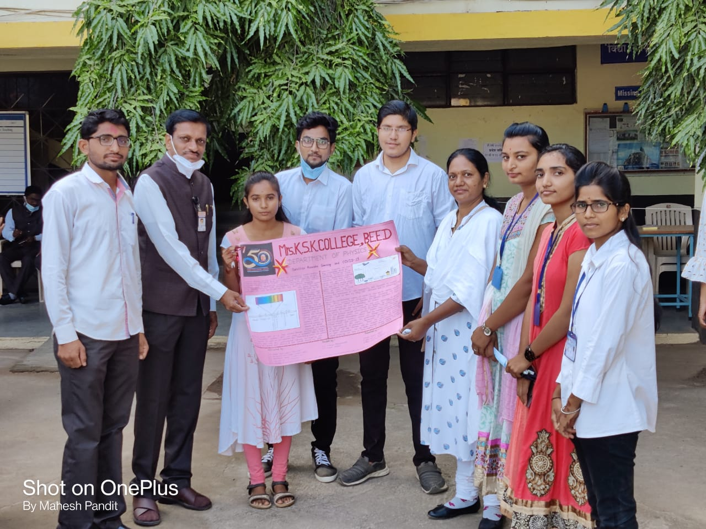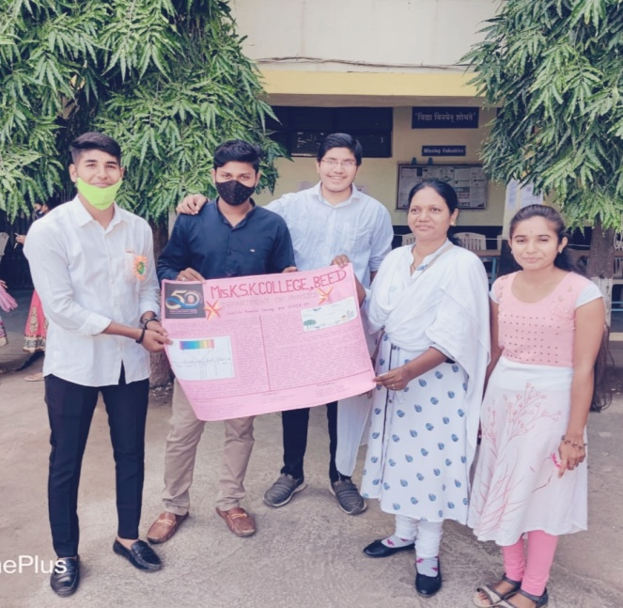
Wall Paper Publication on the occasion of 15, August 2021, entitled “satellite remote sensing and covid-19”, on this occasion Hon’ble vice Principal as well as HOD Dr. S.V. Kshirsagar, Faculties with students.

List of Participated Students-
Sr.No. | Name of Student
1 | Snehal Maske
2 | Gaurav Joshi
3 | Mohini Bhosale
4 | Pratiksha Kanthale
5 | Shital Medhe
6 | Saurabh Dange
7 | Kiran Pattekar

- On the occasion of inaugural function of golden jubilee year of College dated on 7 Sept. 2021, Dr. Shivanand Kshirsagar Vice Principal as well as head of the department, Published his book with the Auspicious hands of Hon’ble chief guests.
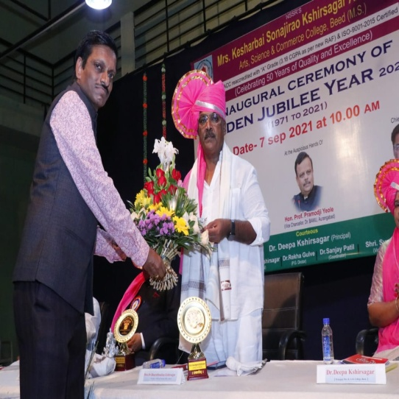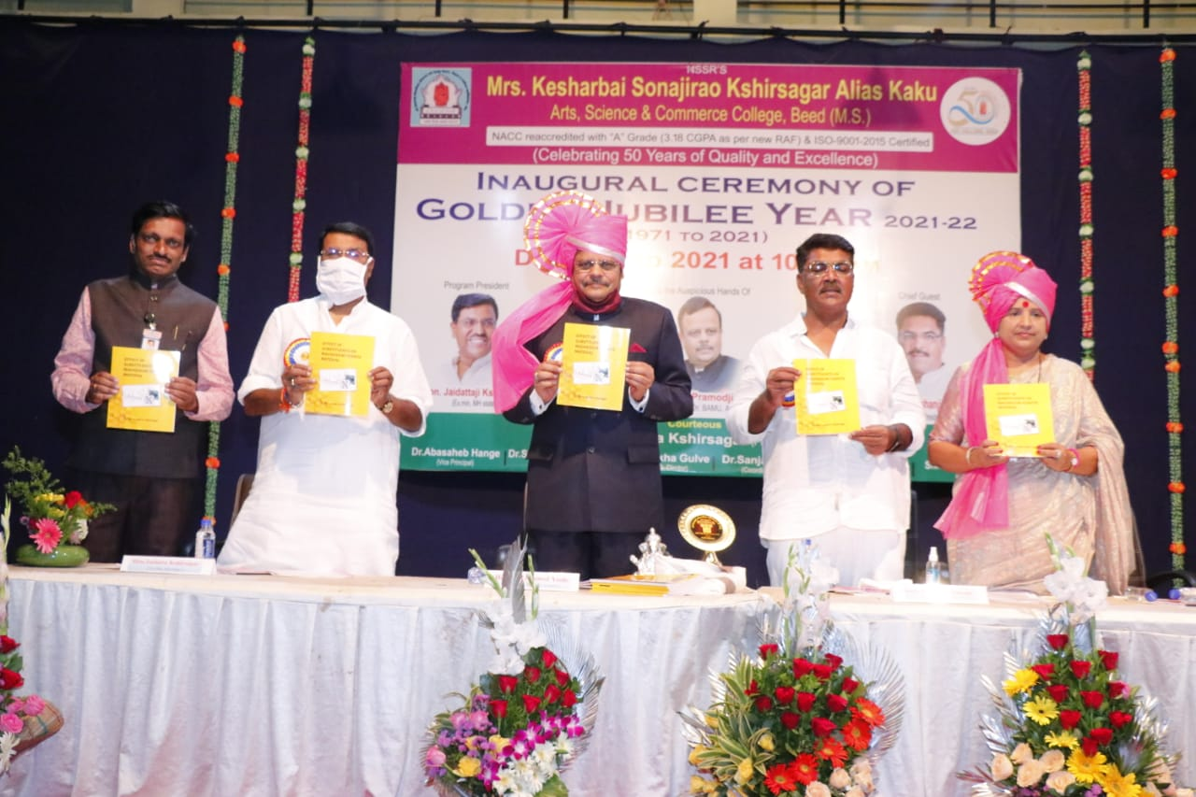
On the occasion of inaugural function of golden jubilee year of College dated on 7 Sept. 2021, Book publication of Dr. Shivanand Kshirsagar with the Auspicious hands of Hon’ble chief guests.
HOD
Dept. of Physics

