Mrs. K.S.K.College,Beed
DEPARTMENT OF PHYSICS
EVENT REPORT
(2022-2023)
Name of Event | - Guest Lecture
Organized by | Department of Physics
Date and Time of Event | 3 Oct. 2022, at 10.50 am to 12.00 pm
Details of Activity | Guest Lecture
Chief Organiser | Principal Dr. Deepa Kshirsagar,
Organiser | Incharge Principal and head of the Department Dr. Shivanand Kshirsagar
Other Faculty as Supervisor | Dr. Pradnya Maheshmalkar,Mr. Rupesh Kokate
No. of Participated Students | 46

Summary of the Event
Department organized a guest Lecture entitled “Properties of matter”on, 3 Oct. 2022 (Monday), at 10.50 am to 12.00 pm. The aim of this lecture had multiple reasons to attend to develop multiple skills like critical thinking, to exchange ideas, reasoning, planning for future, etc., for students and faculties.
The lecture was completed under the guidance of Hon’ble Principal Dr. Deepa Kshirsagar. Also the suggestions and permissions are given by Hon’ble I/Principal as well as HOD of Physics department,Dr. S.V. kshirsagar.
The Guest speaker, Respected Dr. Rupali Kulkarni, Associate Professor, Swa. Sawarkar College, Beed, was heartily welcomed by Hon’ble Vice Principal Dr. Sanjay Patil. Dr. Rupali Kulkarni delivereda very interesting and informative Lecture.She discussed about matter and Properties of matter in detail.
As per the feedback received from the students it was a very good learning experience, the lecture helps students to improve their learning in a more interactive, topic in a specific way.
Hon’ble Vice Principal Dr. Sanjay Patil, P.G. Director, Dr. Satish Maulage, were actively Presided over the Lecture.
Faculties and the students,of B.Sc. I, II and III (46) were present for this Guest Lecture. Efforts are made by Dr. Pradnya Maheshmalkar, Mr. Shivaji Raut, Mr. Anil Jadhav, and Shri Gange Anurath for completion of this Lecture.

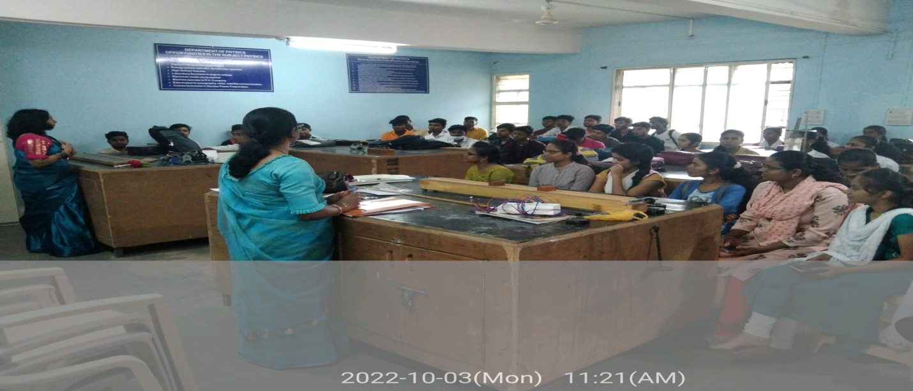
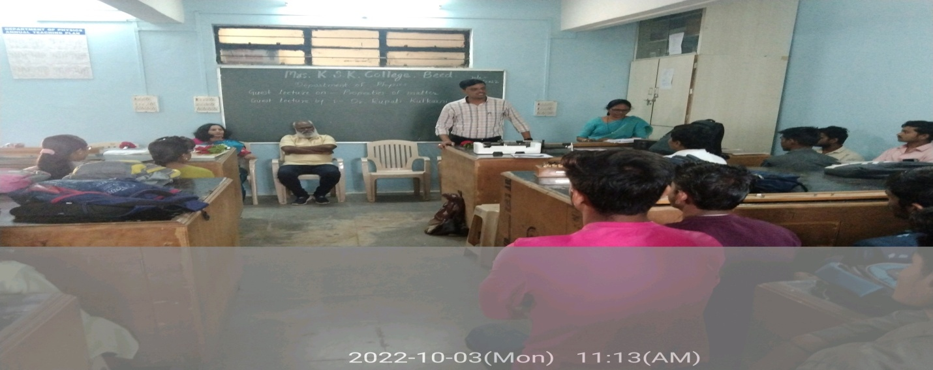
Hon’ble Vice Principal Dr. Sanjay Patil was presided over the Lecture.
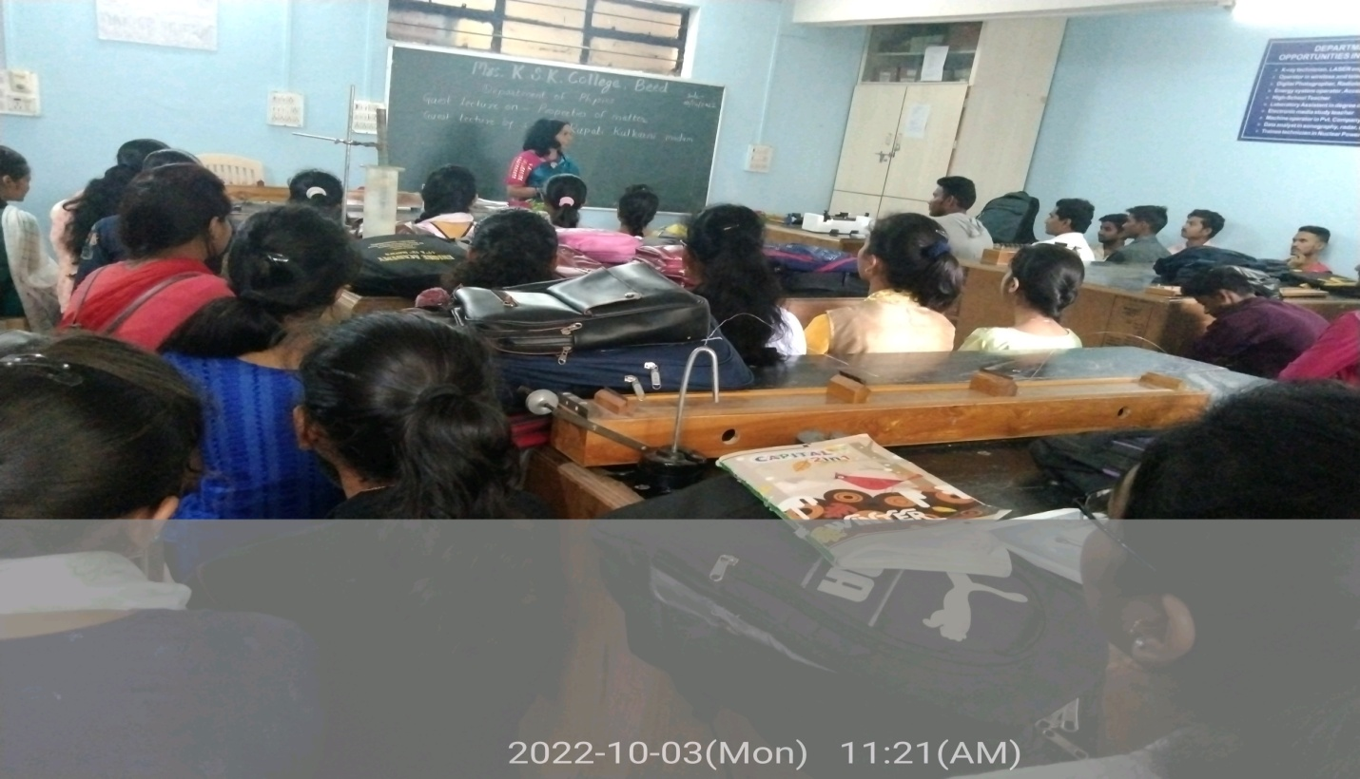
Dr. Rupali Kulkarni deliveringLecture.
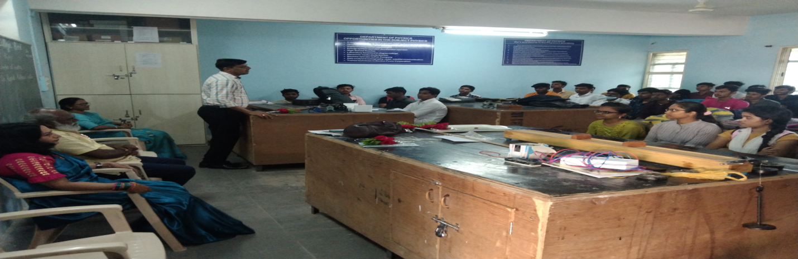
Dr. Satish Maulage, was shared his views.

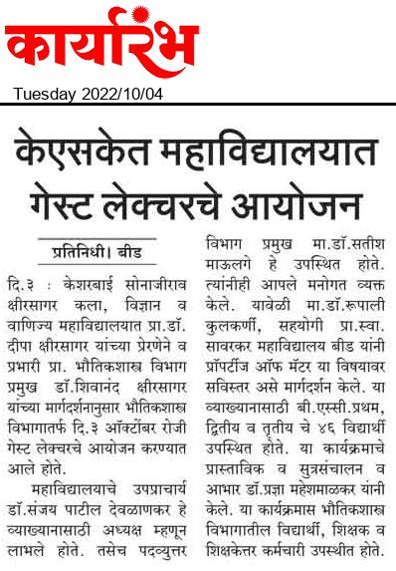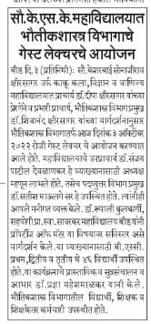

Name of Event | - Science Exhibition
Organized by | Department of Physics
Date and Time of Event | 4 Oct. 2022 at 10.50 am 5.50 pm
Details of Activity | Demonstration of smoke Absorber model
Chief Organizer | Principal Dr. Deepa Kshirsagar,
Organizer | Incharge Principal and head of the Department Dr. Shivanand Kshirsagar
Other Faculty as Supervisor | Dr. Pradnya Maheshmalkar,
No. of Participated Students | 05
Summary of the Event
On 4 Oct. 2022, The 5 students of Physics Students were actively Participated District Level Science Exhibition organized by Science Forum of our College. The Students were demonstrated the smoke Absorber model.
This Exhibition was inaugurated bythe precious hands of Hon’ble Principal Dr. Deepa Kshirsagar.Hon’ble I/Principal as well as HOD of Physics department,Dr. S.V. kshirsagar, Motivated for this exhibition. Vice Principal Dr. Sanjay Patil Devlonkar, P.G. Director, Dr. Satish Maulage, vice Principal of Jr. College, Prof. Sayyad Lala and Supervisor Prof. Jalinder Kolekar were present for this Science Exhibition. The competition was judged by Dr. Tate B.T. Balbhim College, Beed, Dr. Salve U.S. Swa. Sawarkar College, Beed and Dr. Ware R.L. Milliya College, Beed.
Dr. Pradnya Maheshmalkar guided the students for the preparation of Model.

SMOKE ABSORBER MODEL
List of Participated Students
Sr.No. | Name of Student | Class
1 | Ku. Kolhe Sharvari Malhari | B.Sc.I
2 | Ku. Vishwad Rutuja Ravindra | B.Sc.I
3 | Doiphode Mahesh Devidas | B.Sc.I
4 | Munde Rushikesh Shrikisan | B.Sc.I
5 | Sanap Santosh Bajirao | B.Sc.I

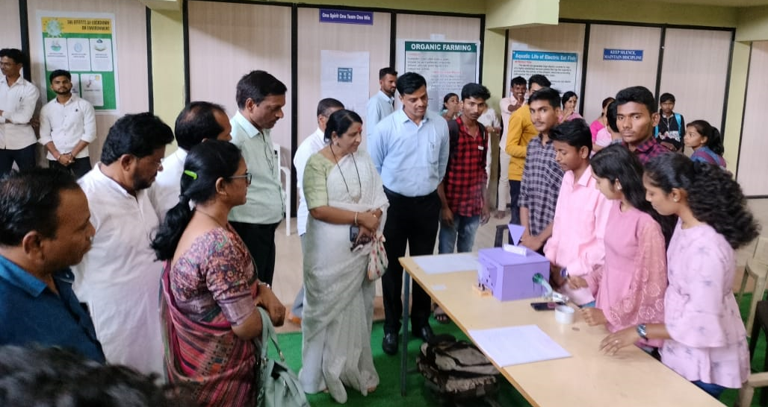
Hon’ble Principal Dr. Deepa Kshirsagar.Hon’ble I/Principal as well as HOD of Physics department,Dr. S.V. kshirsagar, P.G. Director, Dr. Satish Maulage, vice Principal of Jr. College, Prof. Sayyad Lala and Supervisor Prof. JalinderKolekar,Dr. PremchandSirsat, Faculty Dr. Pradnya Maheshmalkar Students and all.

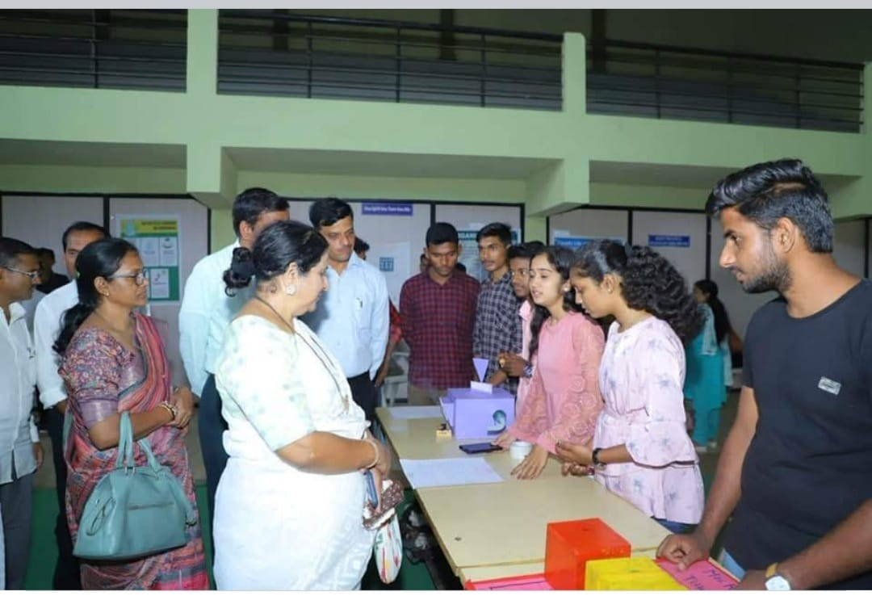
Hon’ble Principal Dr. Deepa Kshirsagar.Hon’ble I/Principal as well as HOD of Physics department,Dr. S.V. kshirsagar,.G. Director,Science Forum Chairman Dr. PremchandSirsat, Dr. Satish Maulage and Faculty Dr. Pradnya Maheshmalkar

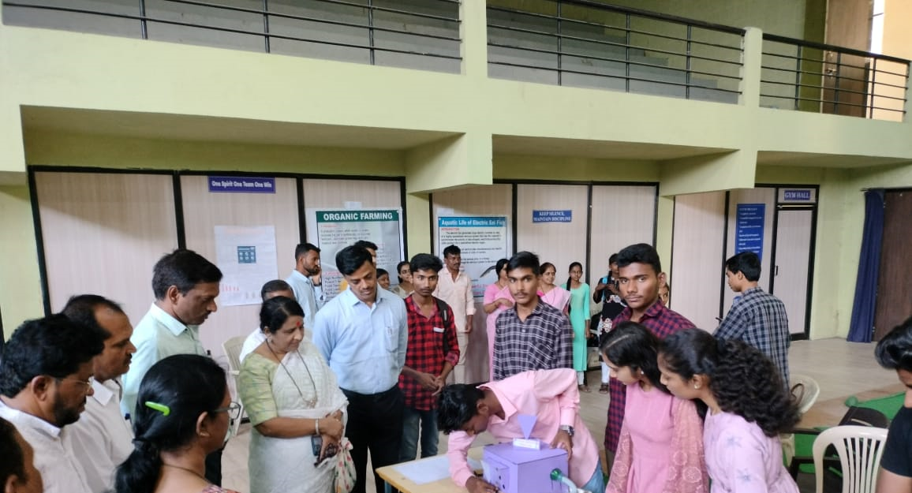
Hon’ble Principal Dr. Deepa Kshirsagar.Hon’ble I/Principal as well as HOD of Physics department,Dr. S.V. kshirsagar,.G. Director, Dr. Satish Maulage, vice Principal of Jr. College, Prof. Sayyad Lala and Supervisor Prof. Jalinder Kolekar

-------------------------------------------------------------------------------------------------------------------------------
Name of Event | - Science Exhibition
Organized by | Department of Physics
Date and Time of Event | 14 and 15 Feb. 2023 at 10.50 am 12.00 pm
Details of Activity | Demonstration of Earh’s Rotation and Day night model
Chief Organizer | I/C Principal Dr. Shivanand Kshirsagar
Organizer | II/C Principal and head of the Department Dr. Shivanand Kshirsagar
Other Faculty as Supervisor | Dr. Pradnya Maheshmalkar, Mr. Kokate R.Y.
No. of Participated Students | 05
Summary of the Event
On 14 and 15 Feb. 2023, the 5 students of Physics Department were actively Participated in Science Exhibition organized by college on the occasion of college gathering. The students were demonstrated the Earh’s Rotation and Day night model. They also highlighted the application of it in the form of tidal energy. In this Science Exhibition, our Departmental Students won Second Prize for this model.
This Exhibition was inaugurated bythe precious hands of Chief Guest Famous Poet Hon’ble Mr. Anant Raut, Vice president and Ex. Principal Hon’ble Dr. Deepa Kshirsagar.Hon’ble I/Principal as well as HOD of Physics department,Dr. S.V. kshirsagar.Vice Principal Dr. Sanjay Patil Devlonkar, Dr. Shivaji Shinde, P.G. Director, Dr. Satish Maulage, vice Principal of Jr. College, Prof. Sayyad Lalaand Supervisor Prof. Jalinder Kolekar were present for this inauguration ceremony of Science Exhibition. HOD of Physics department,Dr. S.V. kshirsagar motivated the students for this exhibition. The competition was judged by Dr. Packore V. P.College, Patoda , Dr. Swati Kulkarni , Siddheshwar Mahavidyalaya, Majalgaon.Dr. Pradnya Maheshmalkar guided the students for the preparation and demonstration of Model.

Earh’s Rotation and Day night model
List of Participated Students
Sr.No. | Name of Student | Class
1 | Ku. Nikita Rajendra Kokate | B.Sc.I
2 | Ku. Muskan Munna Shaikh | B.Sc.I
3 | Doiphode Mahesh Devidas | B.Sc.I
4 | Munde Rushikesh Shrikisan | B.Sc.I
5 | Sanap Santosh Bajirao | B.Sc.I

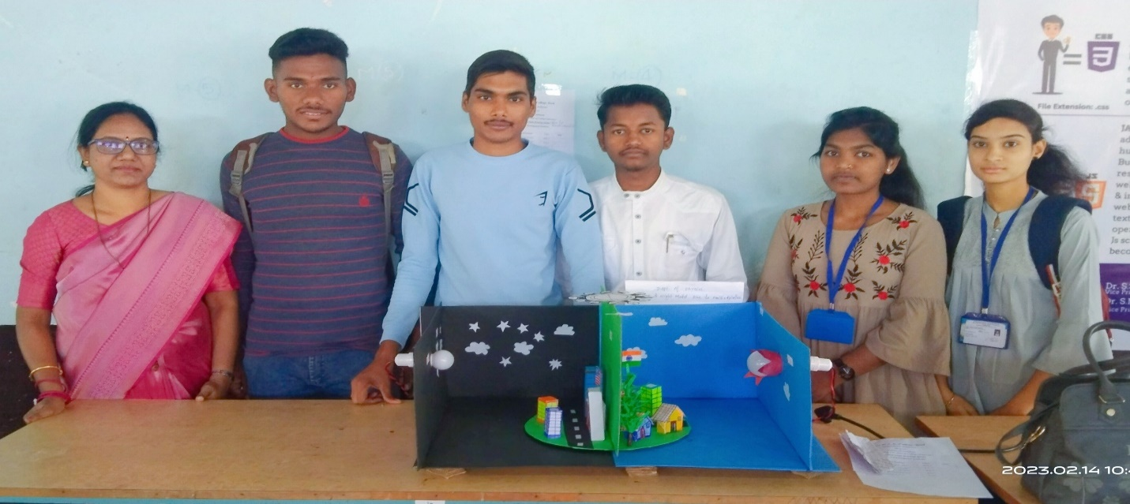
Participated students with Model and Faculty Dr. Pradnya Maheshmalkar

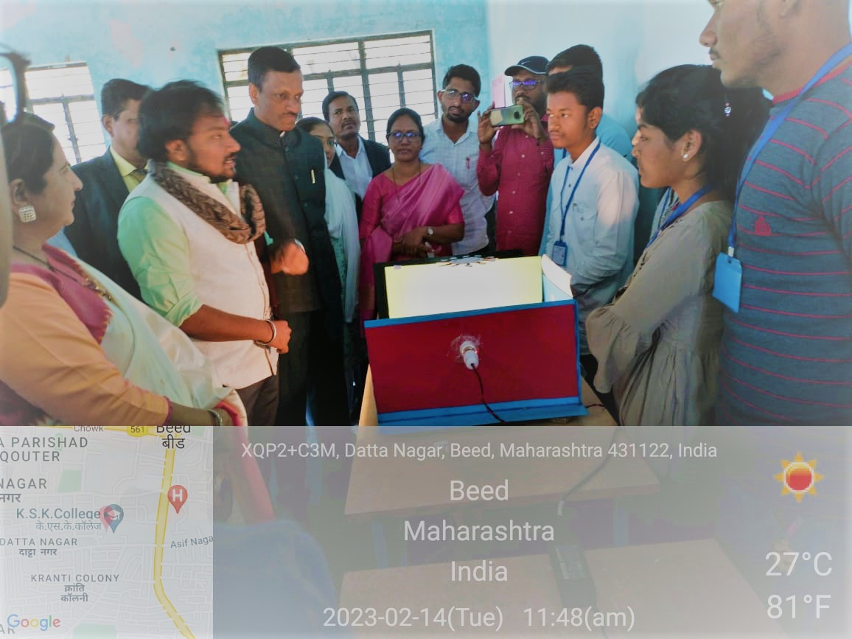
Chief Guest Famous Poet Hon’ble Mr. Anant Raut Asking questions to the students, Also Vice president and Ex. Principal Hon’ble Dr. Deepa Kshirsagar. Hon’ble I/Principal as well as HOD of Physics department, Dr. S.V. kshirsagar. Vice Principal Dr. Sanjay Patil Devlonkar, Dr.Shivaji Shinde, P.G. Director, Dr. Satish Maulage, vice Principal of Jr. College, Prof. Sayyad Lala and Supervisor Prof. Jalinder Kolekar were present.
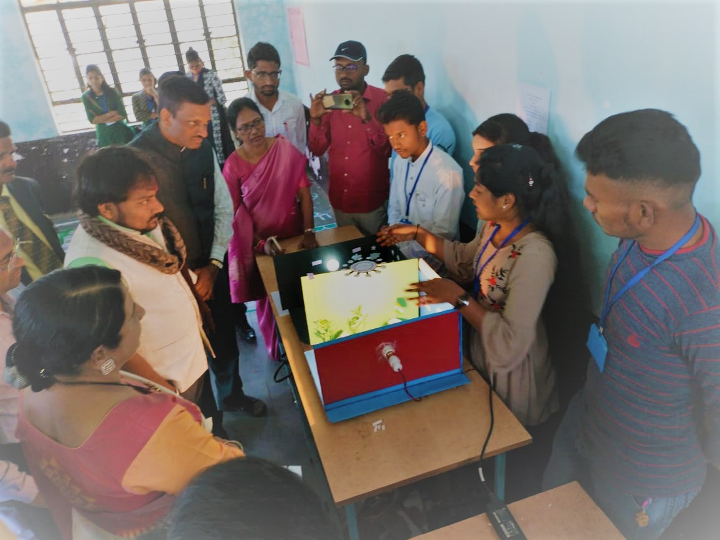
Students Explaining the model made by them to the Chief Guest Hon’ble Mr. Anant Raut, Vice president and Ex. Principal Hon’ble Dr. Deepa Kshirsagar. Hon’ble I/Principal, Dr. S.V. kshirsagar, Vice Principal Dr. Shivaji Shinde, Supervisor Prof. Jalinder Kolekar and Faculties Dr. Pradnya Maheshmalkar, Mr. Rupesh Kokate and all.

-------------------------------------------------------------------------------------------------------------------------------

Name of Event | - Wall Paper Publication
Organized by | Department of Physics
Date and Time of Event | 15 th August 2022 at 7.50 am
Details of Activity | Wall Paper Publication on the occasion of 15 th August, 2022
Chief Organiser | Principal Dr. Deepa Kshirsagar,
Organiser | Incharge Principal and head of the Department Dr. Shivanand Kshirsagar
Other Faculty as Supervisor | Dr. Pradnya Maheshmalkar,Mr. Rupesh Kokate
No. of Participated Students | 06

Summary of the Event
On 15th August 2022, Dept. of Physics was Published Wall Paper on the occasion of Independence day. This 15 th august India will celebrate 75 years of independence of. The main aim of this Wall Paper Publication was, we as Indians pay respect to all the leaders who fought bravely for our nation’s freedom in the past. The title of this wall paper was “Journey to moon” .
This Wall Paper was inaugurated by the precious hands of Hon’ble Principal of our college, Dr. Deepa Kshirsagar. Hon’ble I/Principal as well as HOD of Physics department, Dr. S.V. kshirsagar, Vice Principal Dr. Sanjay Patil Devlonkar, P.G. Director, Dr. Satish Maulage, vice Principal of Jr. College, Prof. Sayyad Lala, and Supervisor Prof. Jalinder Kolekar were also present for the publication. Hon’ble Dr. Deepa Kshirsagar, Dr. S.V. kshirsagar were motivated and guided for it.
Six Students, of B.Sc.II and III. Were, actively participated for this Wall Paper Publication. For this event college staff, students also involved. For Wall Paper Publication, efforts were made by Dr. Pradnya Maheshmalkar and Mr. Rupesh Kokate.
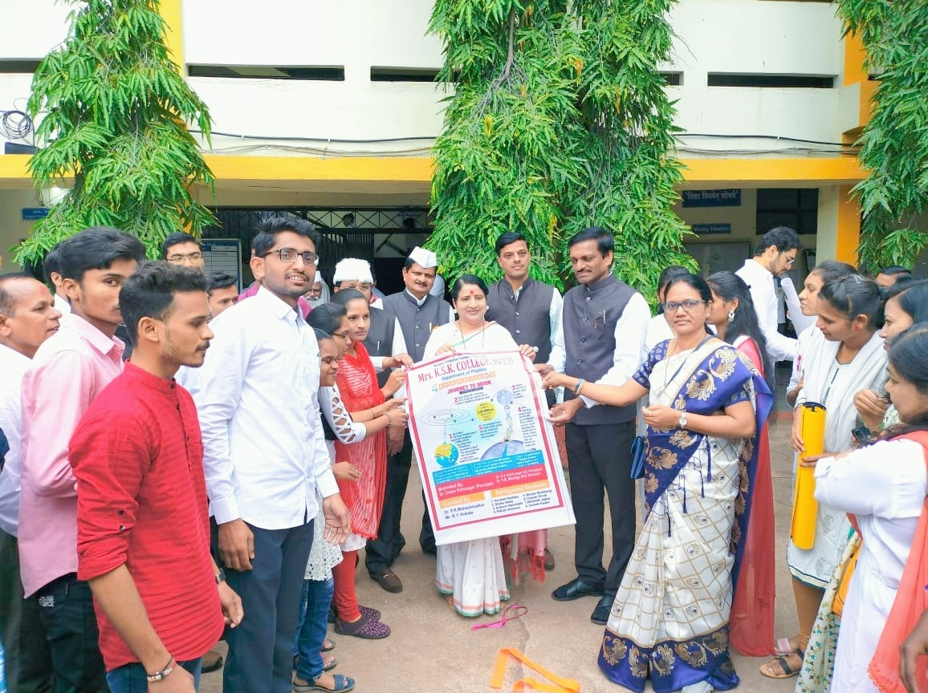
Wall Paper Publication by the precious hands of Hon’ble Principal Dr. Deepa Kshirsagar, Dr. S.V. kshirsagar, Dr. Sanjay Patil Devlonkar, Dr. Satish Maulage, , Mr. Sayyad Lala, and Mr. Jalinder Kolekar
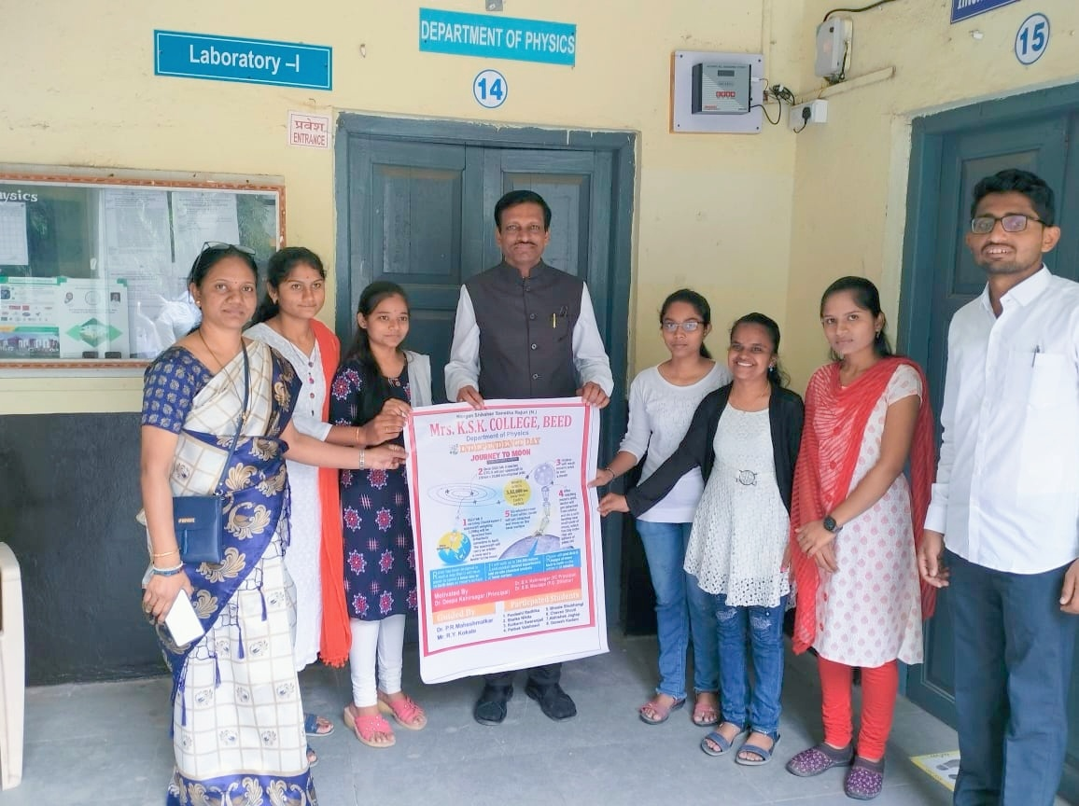
Wall Paper Publication by the precious hands of Hon’ble I/Principal Dr. S.V. kshirsagar.
List of Students participated in wall paper Publication on 15 th August 2022.
Entitled “Journey to moon”
Sr. No. | Name of Students | Year
1 | Kulkarni Swaranjali Sanjay | B.Sc.III.
2 | Pardeshi Radhika Pramod | B.Sc.III.
3 | Shelke Nikita Nitin | B.Sc.III.
4 | Chavan Shruti Laxman | B.Sc.II.
5 | Solanke Aparna Vishnu | B.Sc.II.
6 | Kadam Ganesh Shantiram | B.Sc.II.

Name of Event | - Seminar Competition
Organized by | Department of Physics
Date and Time of Event | 25th August 2022 at 10.50 am
Details of Activity | Seminar competition on the occasion of Rajiv Gandhi Akshy Urja Din
Chief Organiser | Principal Dr. Deepa Kshirsagar,
Organiser | Incharge Principal and head of the Department Dr. Shivanand Kshirsagar
Other Faculty as Supervisor | Dr. Pradnya Maheshmalkar,Mr. Rupesh Kokate
No. of Participated Students | 44

Summary of the Event
On 25th August 2022, Dept. of Physics was organized Seminar competition on the occasion of Rajiv Gandhi Akshy Urja Din. The subject of this competition was “How can we save energy easily?” The main aim of this Seminar competition was to spread awareness about the importance of energy efficiency and conservation of energy develop and use alternative energy sources and also memorialize the birth anniversary of the late Prime Minister of India, Rajivaji Gandhi.
This Competition was inaugurated by Hon’ble I/Principal as well as HOD of Physics department,Dr. S.V. kshirsagar, under the guidance and suggestion of Hon’ble Principal Dr. Deepa Kshirsagar. In the inaugural Speech, he said that, Today, the demand for energy is increasing, due to Increasing population, change of lifestyle due to globalization, Increasing use of Electronic Devices, It is a collective responsibility to overcome this problem and the need to conserve energy through adoption of energy efficient technologies, saving energy results in saving money be at home, offices, school colleges and other places, increases our energy security, reduces the pollution that is emitted from non- renewable sources of energy.Vice Principal Dr. Sanjay Patil Devlonkar, P.G. Director, Dr. Satish Maulage, vice Principal of Jr. College, Prof. Sayyad Lala, and Supervisor Prof. Jalinder Kolekar were actively Presided over the function. The competition was judged by Prof. Rahul Sonawane (Dept of Chemistry, Jr, College) and Prof. Shivaji Raut (Dept of Physics, Jr, College). From all Participants 3 Participants selected for 1st, 2nd, 3rd prize & awards were given by the hands of respected Dias.First Prize – Ku. Shinde Taniksha (B.SC. I), Second Prize – Ku. Pathak Vaishanvi (B.Sc. II), Third Prize – Ku. Chavan Shital (B.Com I)
Dr. Pradnya Maheshmalkar delivered the introductory speech. She declaredAim behind the competition through her speech and expressed the picture of departmental activities Six Students were participated in this competition and 40 students of B.Sc., B.A, B.Com I, II and III were present for this Seminar competition. In this programme college staff, students also involved & Co-operated.
This competition was anchored by Dr. P.R. Maheshmalkar. Vote of thanks wasproposed by Mr. Rupesh Kokate .For completion of Seminar competition, efforts are made by Dr. Pradnya MaheshmalkarandMr. Rupesh Kokate.

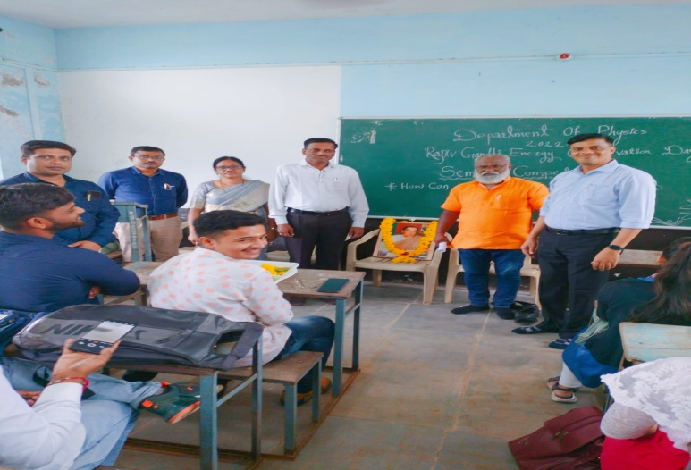
I/ Principal Hon’ble Dr. Shivanand Kshirsagar, Vice Principal Dr. Sanjay Patil Devlonkar, P.G. Director Dr. Satish Maulage, Judges Prof. Rahul Sonwane, Prof. Shivaji Raut, Dr. Pradnya Maheshmalkar and Students, for Seminar competition, on the occasion of Rajiv Gandhi Akshy Urja Din conducted by Department of Physics dated on 25, August, 2022.

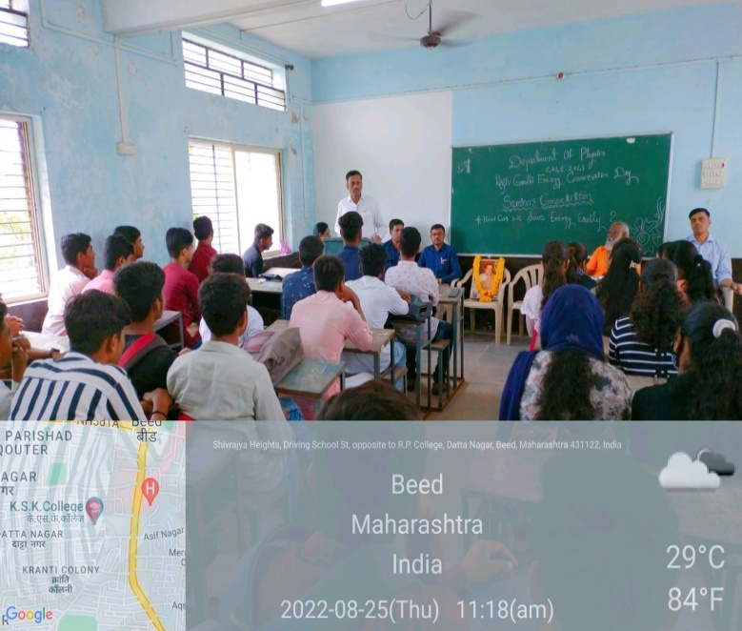
In the Inaugural function of seminar competition, on the occasion of Rajiv Gandhi Akshy Urja Din I/ Principal as well as HOD, Hon’ble Dr. Shivanand Kshirsagar delivered the Inaugural Speech, respected dais and Students.

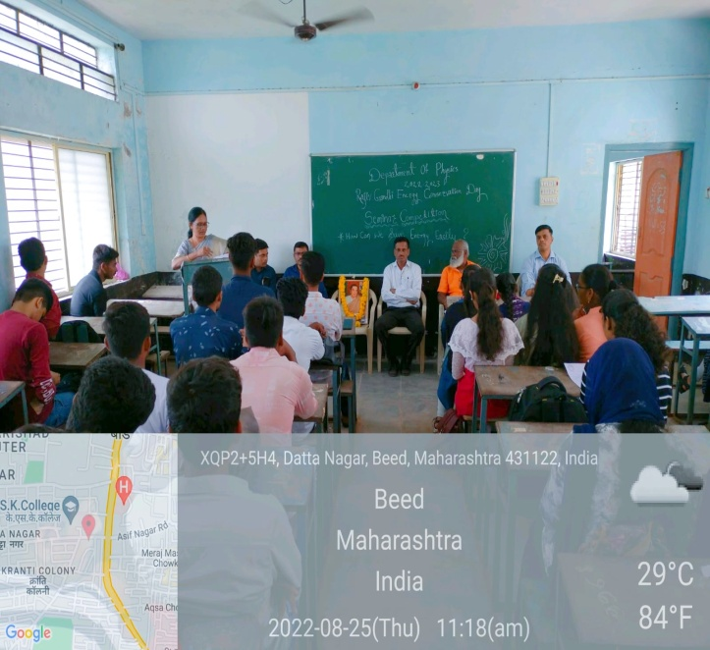
In the Inaugural function of seminar competition, on the occasion of Rajiv Gandhi Akshy Urja DinDr. Pradnya Maheshmalkar delivering the Introductory Speech, Respected dais and Students.
Winner students of the Seminar competition, Judges Prof. Rahul Sonawane, Prof. Shivaji Raut (Dept of and Dr. P.R.Mahesh,malkar, on the occasion of Rajiv Gandhi Akshy Urja Din conducted by Department of Physics dated on 25, August, 2022

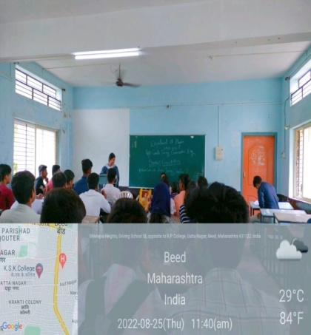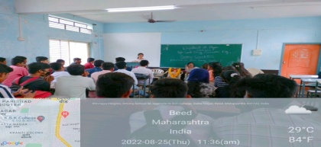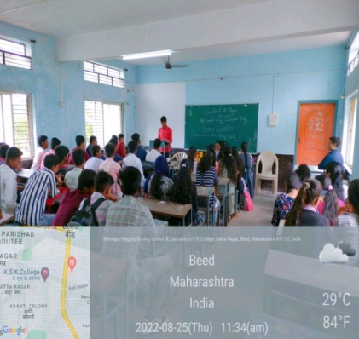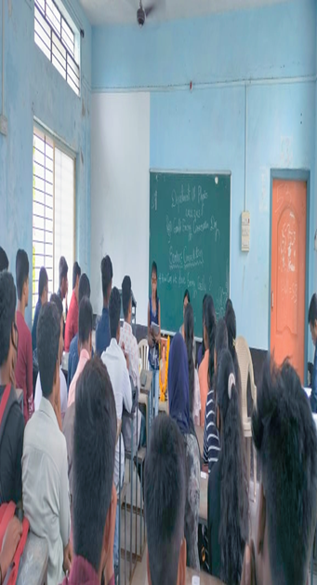
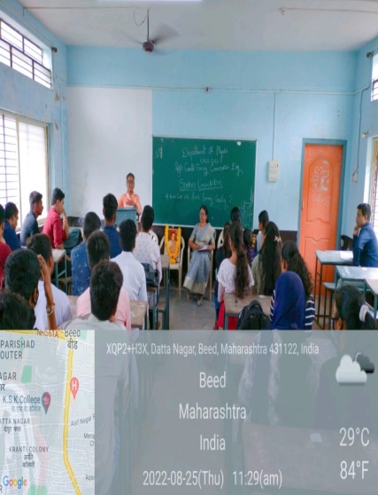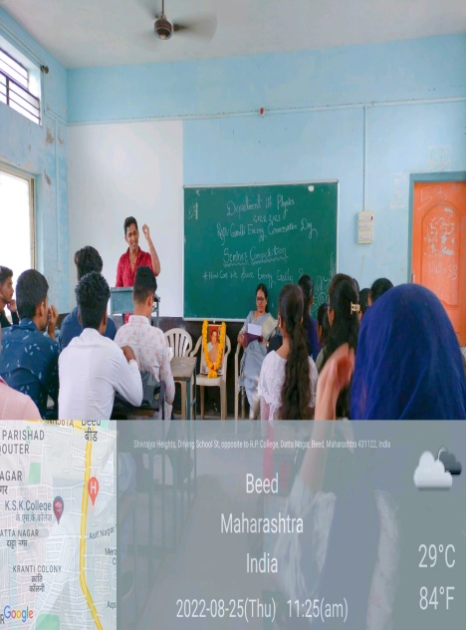
The Participated Students of Seminar competition, on the occasion of Rajiv Gandhi Akshy Urja Din conducted by Department of Physics dated on 25, August, 2022.

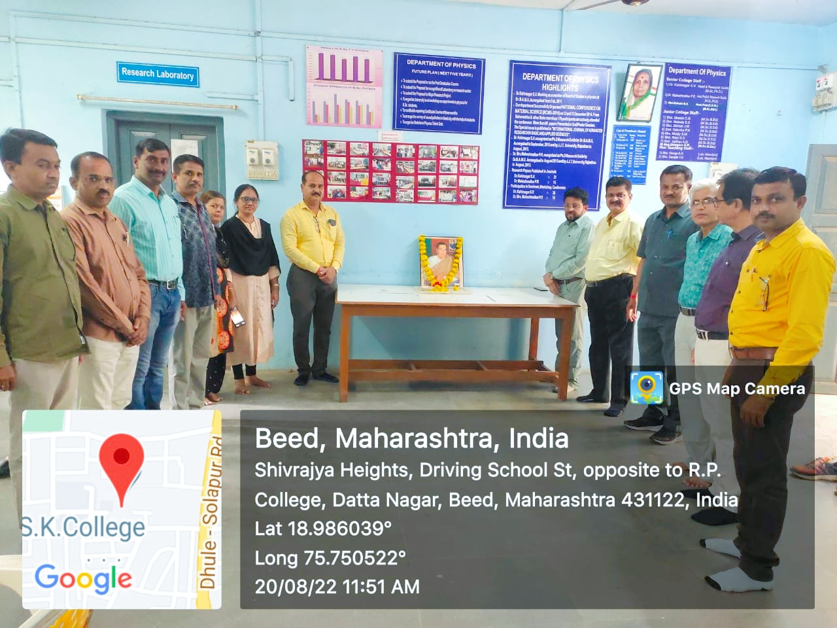
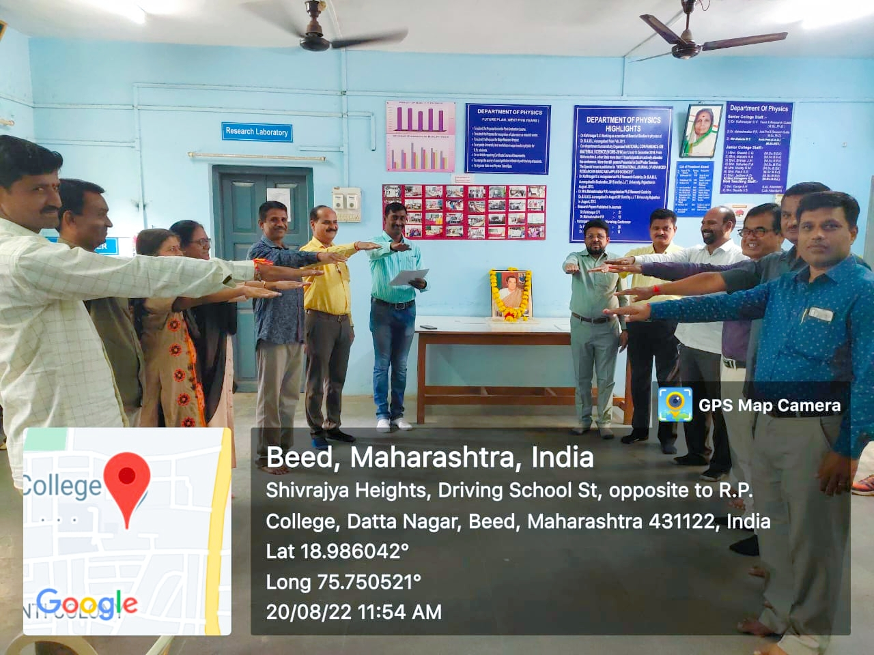

------------------------------------------------------------------------------------------------------------------------------------------

EVENT REPORT
Wall Paper Publication on the occasion of 26 January 2023, on the topic
entitled “Photoelectric effect”

Name of Event | - Wall Paper Publication
Organized by | Department of Physics
Date and Time of Event | 26 January 2023, 7.50 am
Details of Activity | Wall Paper Publication on the occasion of 26 January 2023
Chief Organiser | Incharge Principal and head of the Department Dr. Shivanand Kshirsagar
Organiser | Dept. of Physics
Other Faculty as Supervisor | Dr. Pradnya Maheshmalkar,Mr. Rupesh Kokate
No. of Participated Students | 03

Summary of the Event
On 26 January 2023, Dept. of Physics was Published Wall Paper on the occasion of Republic day. The title of this wall paper was “Photoelectric effect”.
This Wall Paper was inaugurated by the precious hands of Vice president and Ex. Principal Hon’ble Dr. Deepa Kshirsagar.Hon’ble I/Principal as well as HOD of Physics department, Dr. S.V. kshirsagar. Vice Principal Dr. Sanjay Patil Devlonkar, Dr. Shivaji Shinde, P.G. Director, Dr. Satish Maulage, vice Principal of Jr. College, Prof. Sayyad Lala and Supervisor Prof. Jalinder Kolekar were present for the publication. For this event college staff, students also involved. Hon’ble Dr. S.V. kshirsagar was motivated and guided for it.
Three Students, of B.Sc.I year Were, actively participated for this Wall Paper Publication. For Wall Paper Publication, efforts were made by Dr. Pradnya Maheshmalkar and Mr. Rupesh Kokate.

List of Participated Students
Sr.No. | Name of Students | Class
1 | Ku. Kolhe Sharwari | B.Sc. I year
2 | Ku. Nirdhar Sarita | B.Sc. I year
3 | Ku. Kokate Nikita | B.Sc. I year

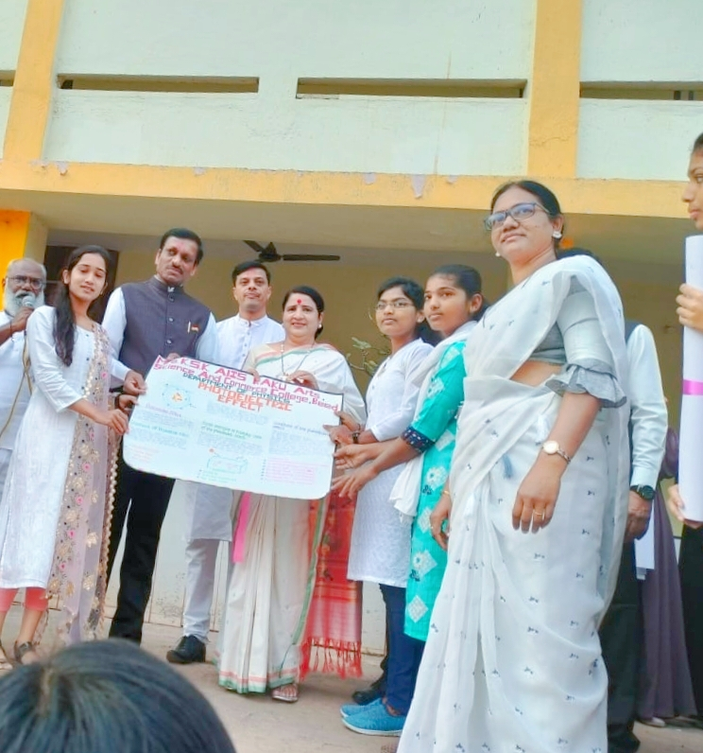
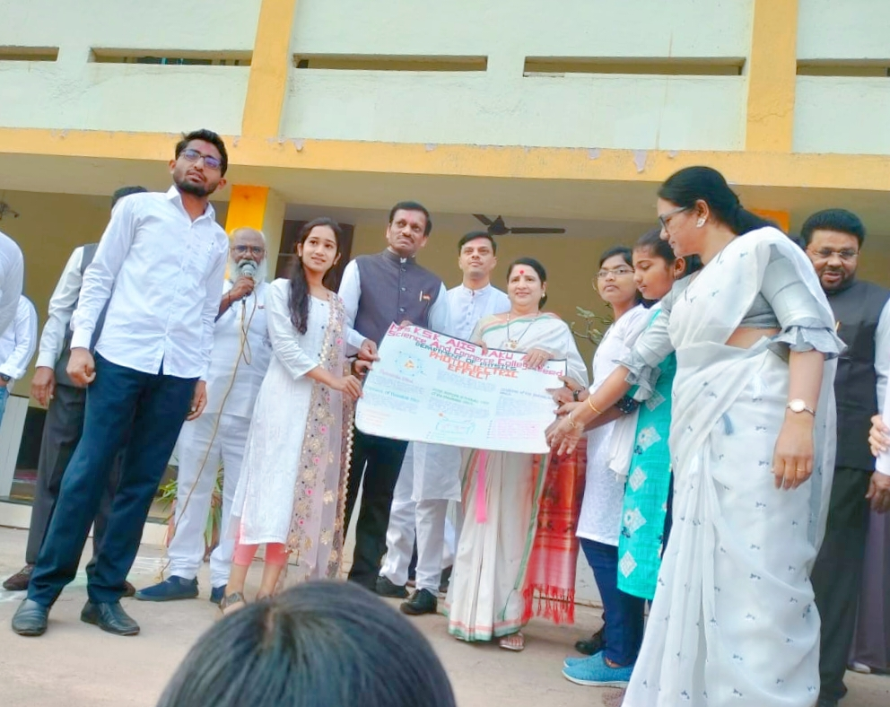
Departmental students Published Wall Paper on the occasion of 26 January 2023, on the topic entitled “ Photoelectric effect” by the auspicious hands of Vice president of Institute Hon’ble Dr. Deepa Kshirsagar, I/Principal Dr. Shivanand Kshirsagar,in the presence of Vice principal Dr. Sanjay Patil, Mr. Sayyad Lal, PG Director Dr. Satish Maulage and Faculties.
------------------------------------------------------------------------------------------------------------------------------------------
EVENT REPORT
(2022-2023)
Name of Event | - “Online National level Physics Quiz Competition 2023 ”.
Organized by | Department of Physics
Date and Time of Event | 27th February 2023(Monday) at 11.00 am to 12.00 pm
Details of Activity | Online National level Physics Quiz Competition on the occasion of National Science Day (28 Feb. 2023)
Chief Organizer | I/C Principal Dr. Shivanand Kshirsagar and head of the Department Dr. Shivanand Kshirsagar
Organizer | Dr. Pradnya Maheshmalkar,
Other Faculty as Supervisor | Mr. Rupesh Kokate
No. of Participated Students | 160

Summary of the Event
On the occasion of National Science Day (28 Feb. 2023), Dept. of Physics organized “Online National level Physics Quiz Competition 2023”. National Science Day is a great occasion to highlight the importance of science in the world and to encourage young minds to take up this subject. Integrated approach in science and technology for a sustainable future.
The main aim of this competition is to spread awareness about the contribution of Sir C.V. Raman and to mark the discovery of the Raman effect, for which Indian Physicist Sir C.V. Raman won the Nobel Prize.In this Competition 160 Students Participated from the link given below. https://docs.google.com/forms/d/e/1FAIpQLSdhZjokd6ObFli10godsxzDipvsiD9WmldIeDFv_vw7xnO4Yg/viewform?usp=sf_link
From all Participants 3 numbers were drawn for 1st, 2nd, 3rd prize & E-certificates were provided to the students who participated in the competition after submitting the quiz successfully.
First three ranked participants will be declared as prize winners. First Prize- Rs. 1000/- and e-certificate, Second Prize – Rs. 700/- and e-certificate and Third prize- Rs. 400/- and e-certificate. The first number went to Miss Sanjana Bhagat, B.Sc. III year, KTHM College. Nasik, who secured 88 Points. The second place shared among seven students who scored equally 86 points while third place was shared between two students who scored equal points i.e. 84 points.
For completion of Seminar competition, efforts are made by Dr. Pradnya Maheshmalkarand Mr. Rupesh Kokate.

Name of Event | - School College Interaction
Organized by | Department of Physics
Date and Time of Event | 31 January,2023 at 9.00 am to 10 am
Details of Activity | To create Interest, Curiosity in science among Students. To Inform about Science through various demonstrations and equipments.
Chief Organiser | Incharge Principal and head of the Department Dr. Shivanand Kshirsagar
Organiser | Dept. of Physics
Other Faculty as Supervisor | Dr. Pradnya Maheshmalkar, Mr. Shivaji Raut, Mr. Rupesh Kokate
No. of Participated Students | 66 (of 9th Std) of Shri. Shivaji Vidyalaya, Beed

Summary of the Event
Dept. of Physics of our college, organized the School College interaction, on 31 January,2023.Hon’ble I/Principal as well as HOD of Physics department,Dr. S.V. kshirsagar, Motivated and Suggested for this event. The 46 students of 9th class of Shri. Shivaji Vidyalaya, Beed with three teachers Named Shri Sawant H.R and Shri Zunzurke V.B. were interact with us during the time of 9.00 am to 10 am. In the Interaction Dr. Pradnya Maheshmalkar, gave the information of Raman effect by performing the experiment of spectrometer with the fine spectrum of mercury source. Also the optical devices.She also explained images formed by the lenses and mirrors. Mr. Shivaji Raut Introduces about ohm’s law with the electrical equipment’s like ammeter, voltmeter. He also explained the working of screw gauge, vernier caliper, sound production by tuning forks etc.,
Forsuccess of School College interaction, efforts are made by Dr. Pradnya Maheshmalkar, Mr. Shivaji Raut, Mr. Pandit andMr. Rupesh Kokate.

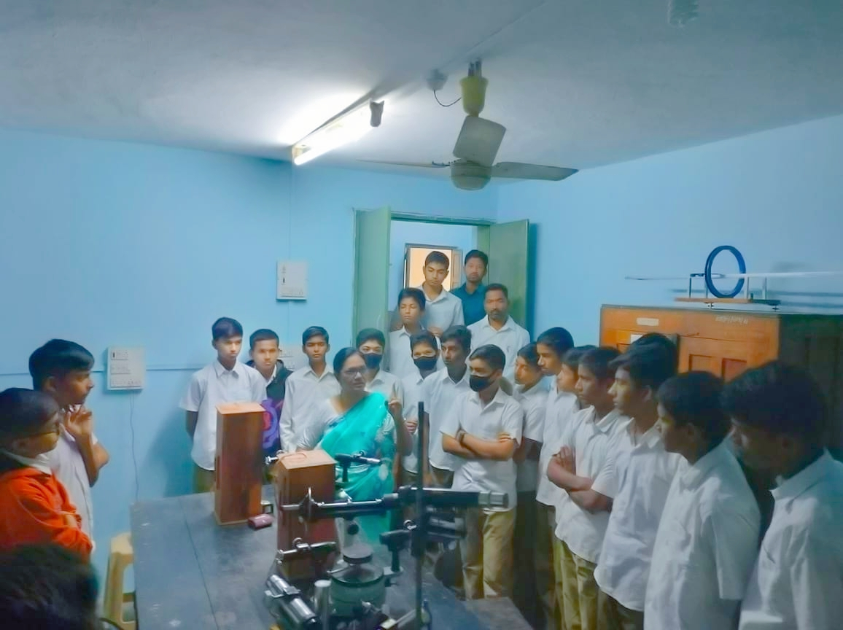
In School- College interaction Dr. P.R.Maheshmalkar Demonstrated the Experiments related to optical devices to students.

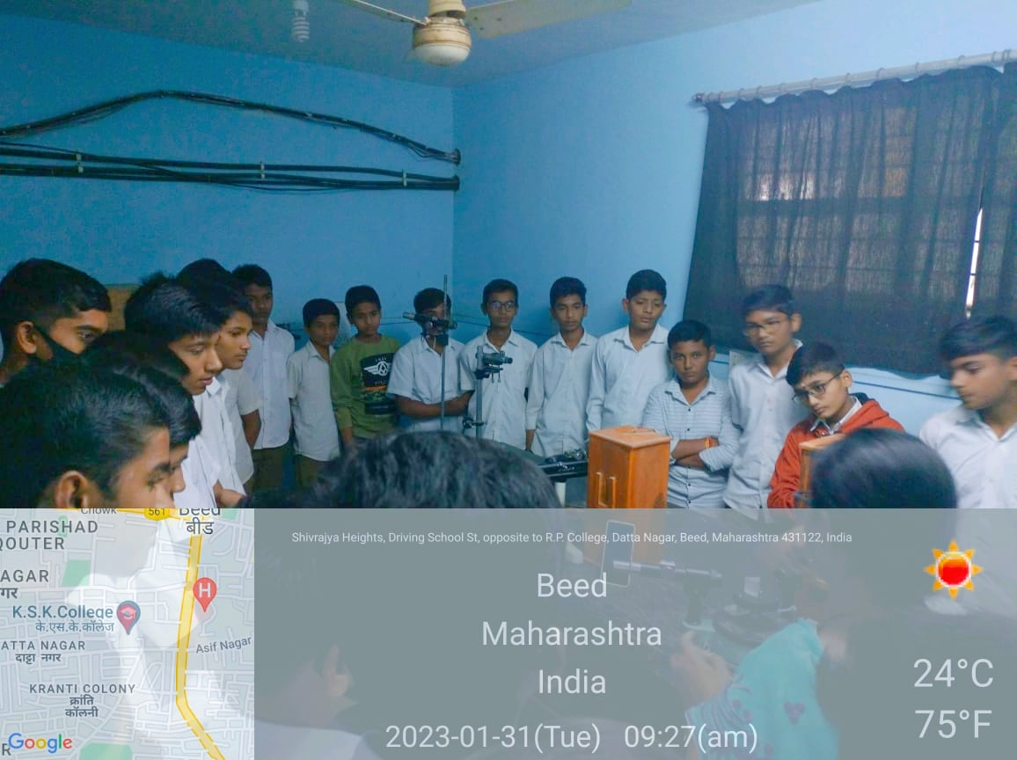
In School- College interaction Dr. P.R.Maheshmalkar Demonstrated the Experiment to students. 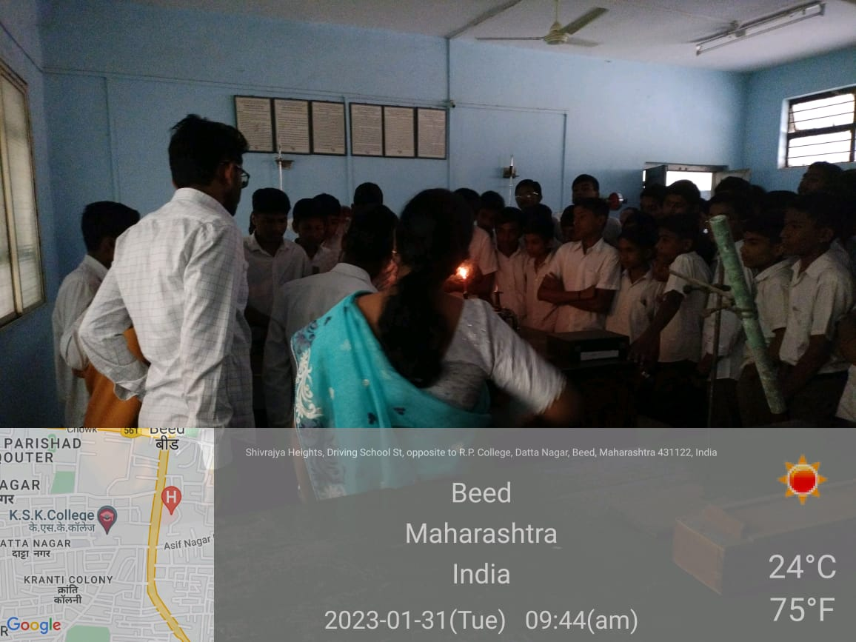
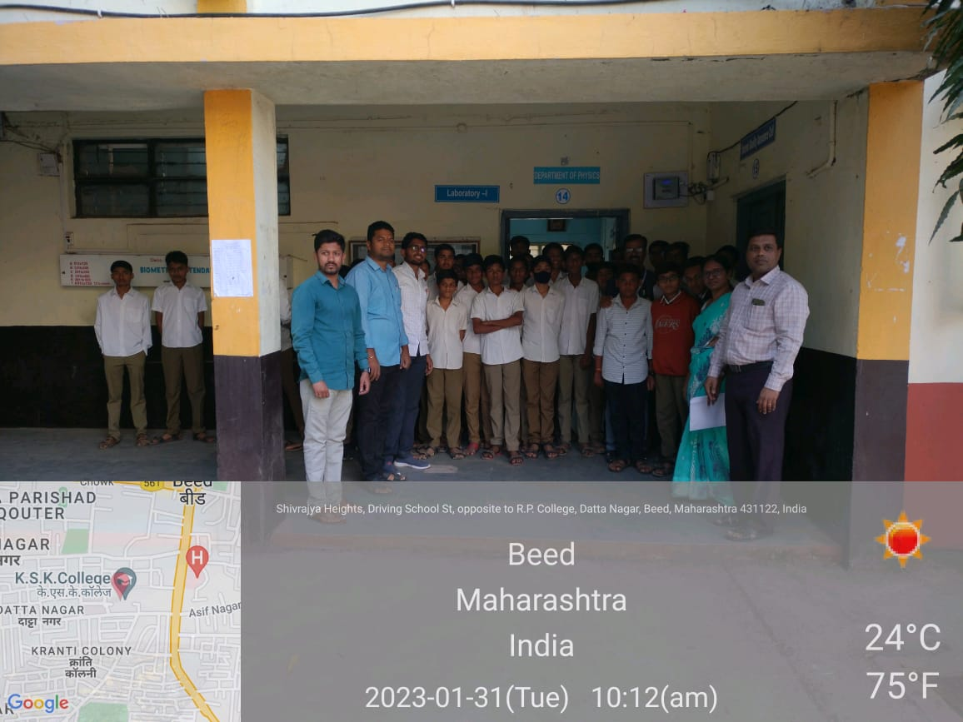
In School- College interaction the students,staff members of Shri. Shivaji Vidyalaya, Beed visited our Physics Dept. and our Departmental staff.

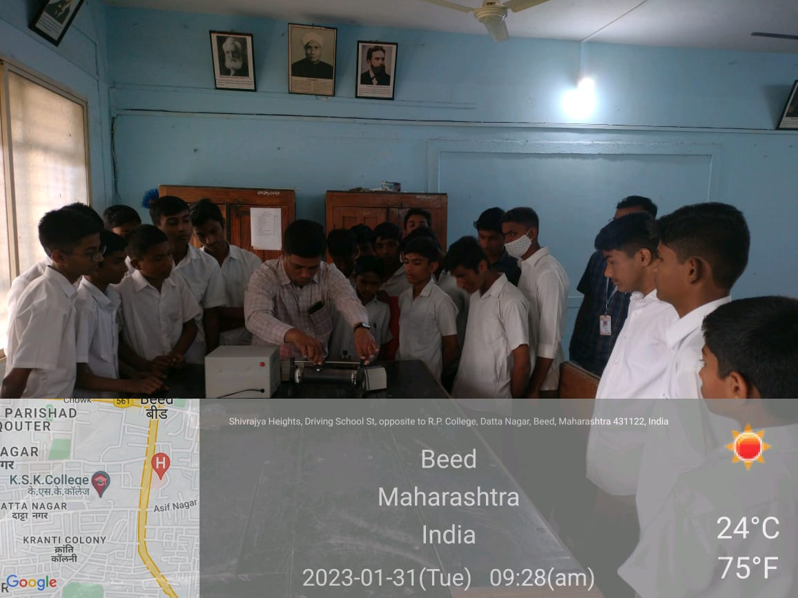
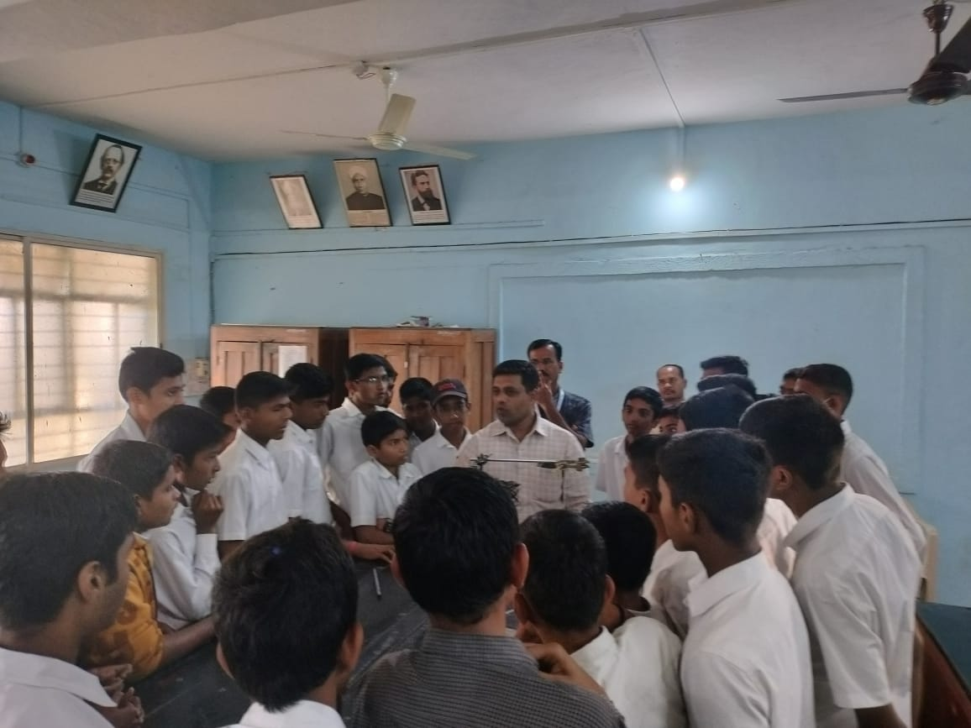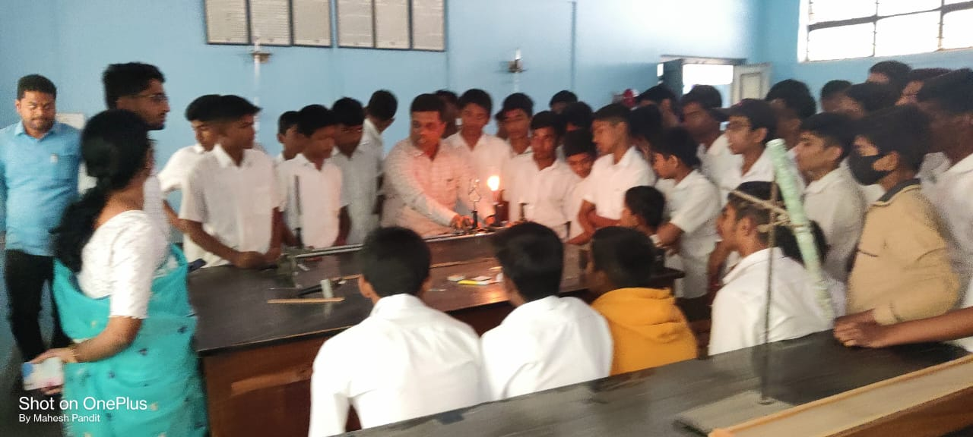
School- College interaction Mr. S.S.Raut Sir Demonstrated the Experiment to students.

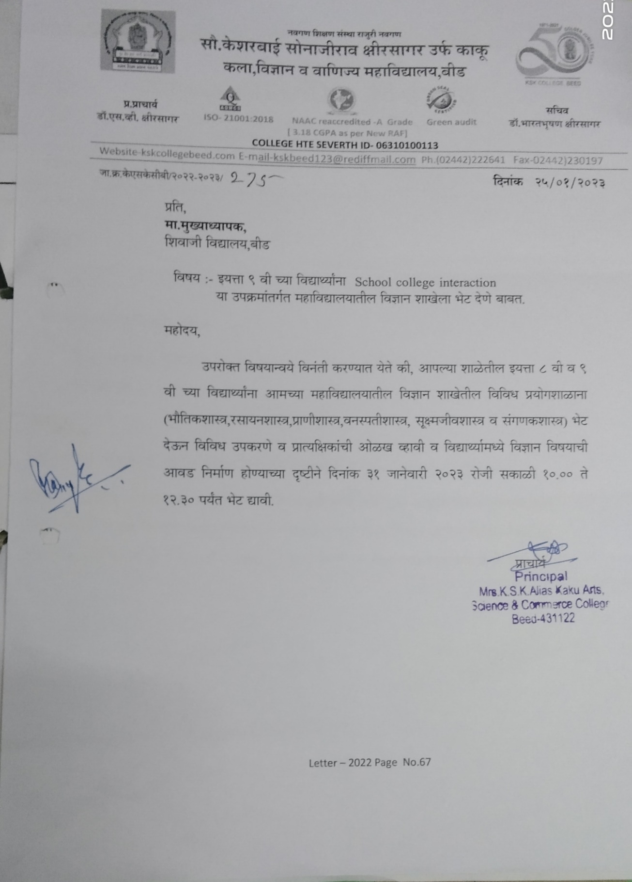

--------------------------------------------------------------------------------------------------------------------
- Dept. organized seminars and Group discussion among Students.

-------------------------------------------------------------------------------------------------------------------------------

- Dr. P.R.Maheshmalkar Published her book entitled “Heat and Thermodynamics”, for B.Sc. I year , CBCS, First sem. Paper II

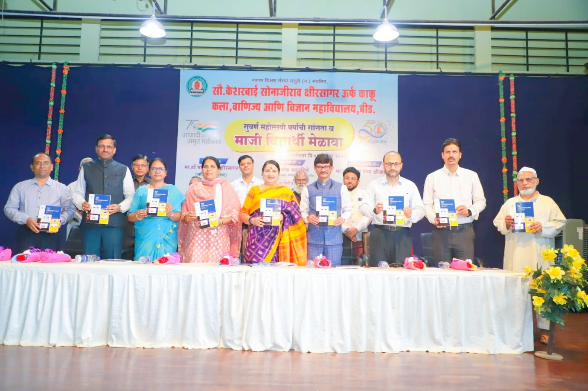
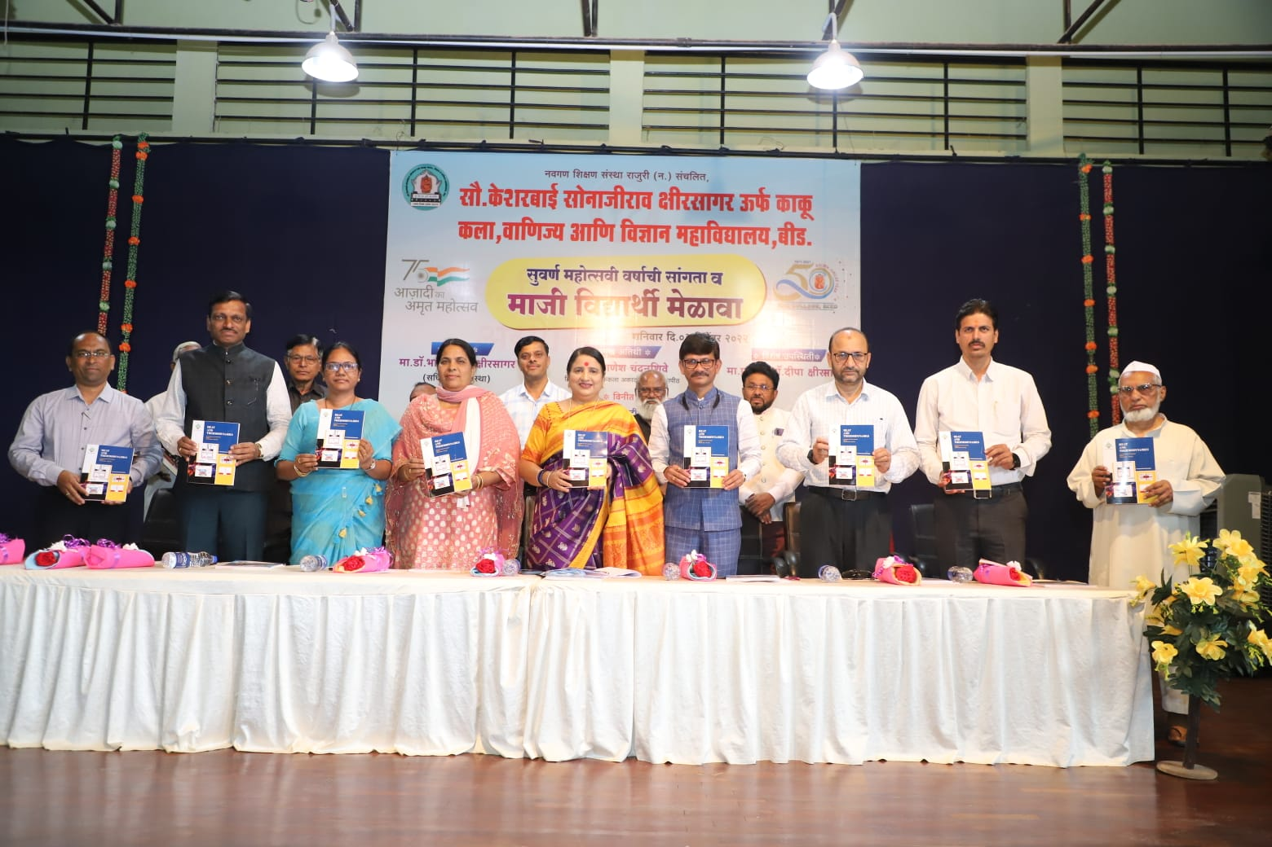
On the occasion of Book publication dated on 3 dec. 2022 entitled “Heat and Thermodynamics”,of Dr. Pradnya Maheshmalkar,by the auspicious hands of Chief Guest Hon’ble Dr. Ganesh Chandanshive, Hon’ble Principal Dr. Deepa Kshirsagar, I/Principal Dr. Shivanand Kshirsagar,Vice principal Dr. Sanjay Patil, Dr. Shivaji Shinde, Mr. Sayyad Lal, PG Director Dr. Satish Maulage, all the former principals and Aluminies presided over the dais.

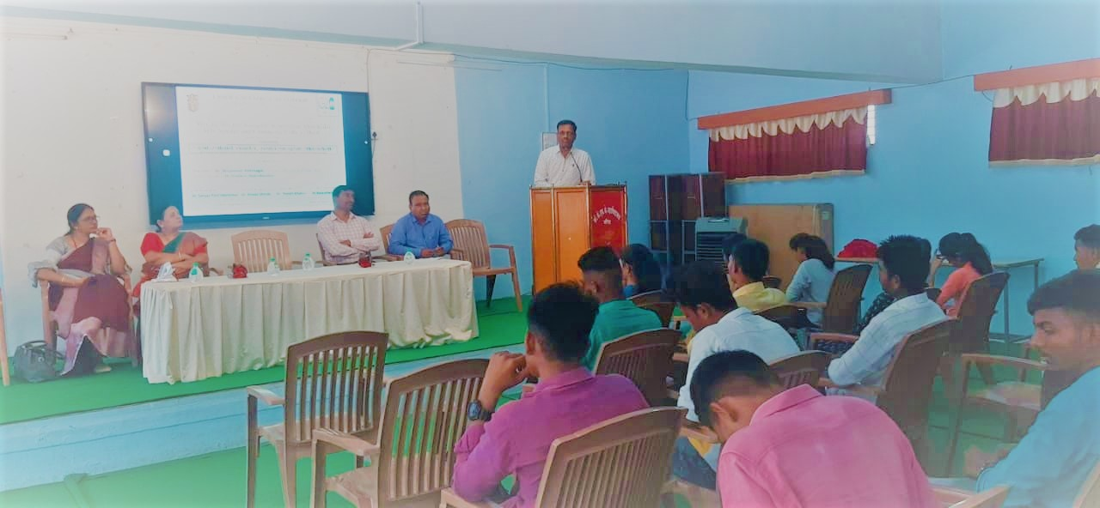
Dr. P.R.Maheshmalkar delivered a Lecture on “Conservation of energy sources, eco-friendly lifestyle”. in the workshop organised,UNDER G20 ENERGY TRANSITION WORKING GROUP (ETWG) and NSS, NCC Dept. of Mrs. K.S. K. College, Beedon 17 th May 2023. On this occasion President of this workshop Dr. Shivanand Kshirsagar, Principal of our college, delivering the presidential remark. NSS P.O. Dr. Pandit Khakre, NCCCaptain Dr. BalasahebPote, Dr. Sandhya Jogdand presided over this program. Staff AND Students.

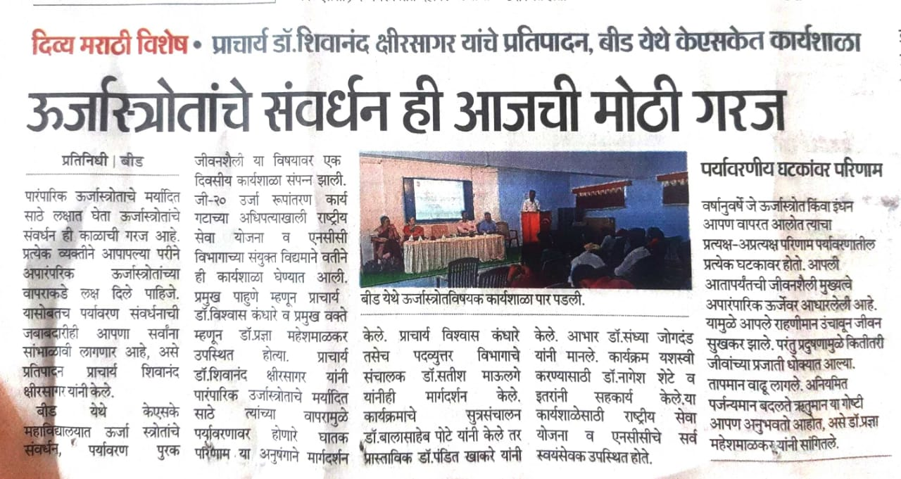

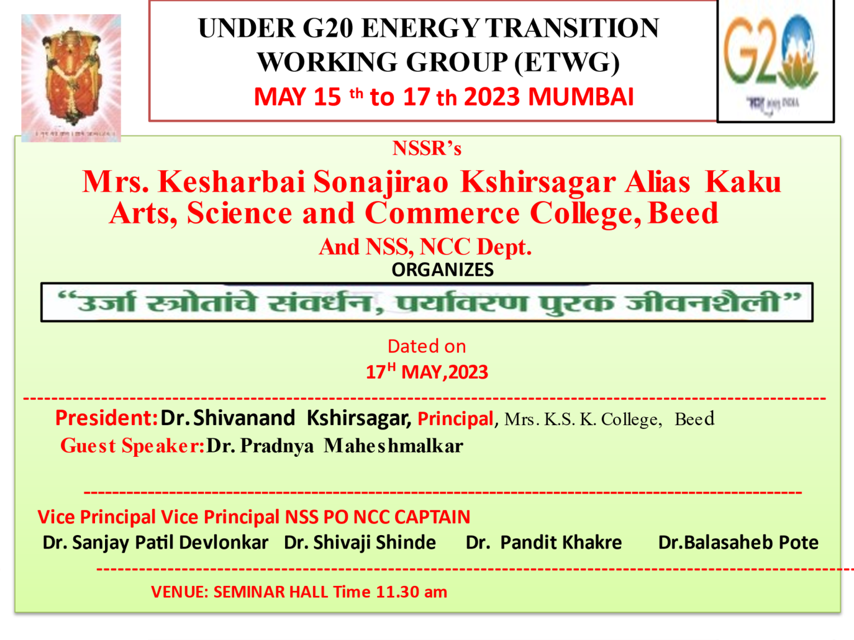
Poem Recitation on the occasion of “Marathi bhasha pandarwada organized by Dept. of Marathi, of our college on 18 jan. 2023at 10. Am .
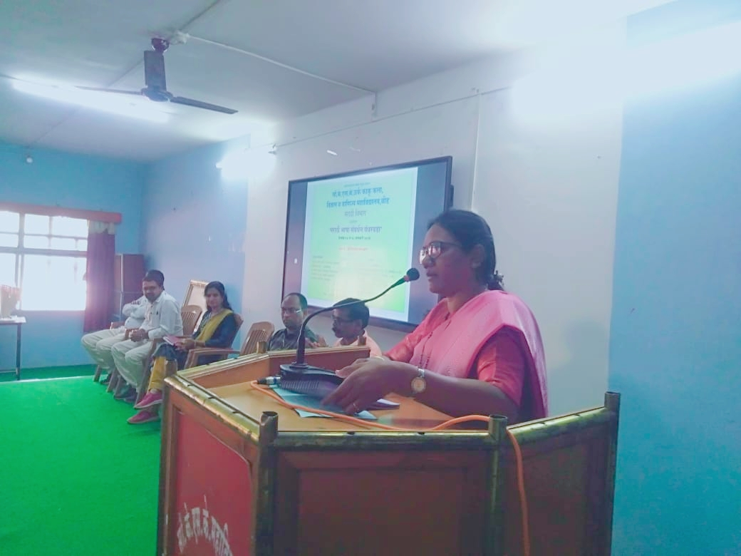
Respected Dr. Shivaji Shinde, Vice Principal, poets and poetess presided over the dais. Dr. Pradnya Maheshmalkar Poem Reciting, on the occasion of “Marathi bhasha Pandarwada organized by Dept. of Marathi, of our college on 18 jan. 2023 at 10. Am .
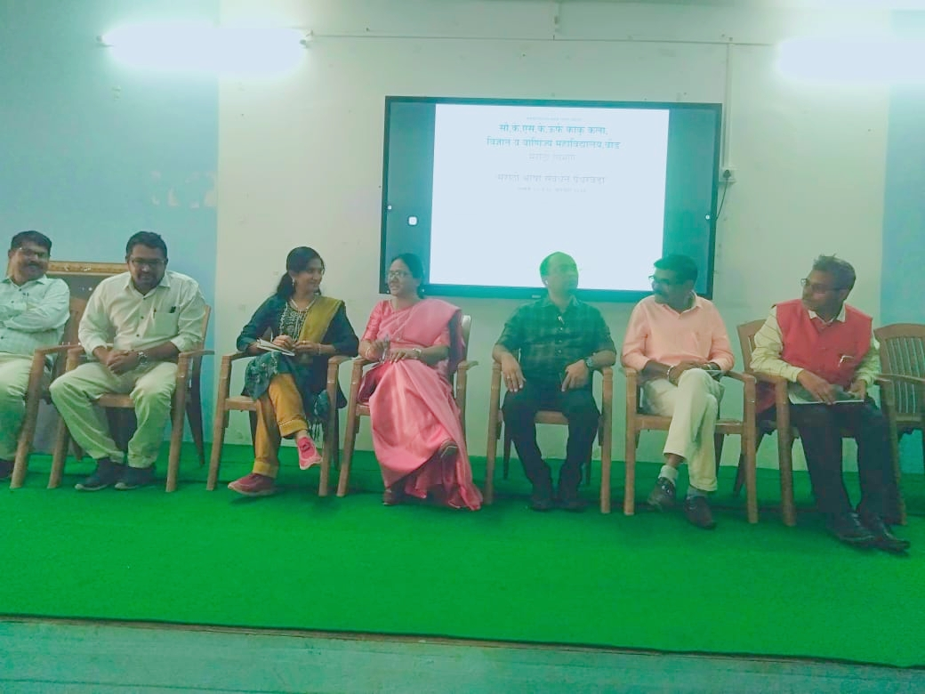Respected Dr. Shivaji Shinde, Vice Principal and poets and poetress presided over the dais on the occasion of “Marathi bhasha Pandarwada organized by Dept. of Marathi, of our college on 18 jan. 2023 at 10. Am .
Lecture Delivered on “Value of Freedom in the Constitution”
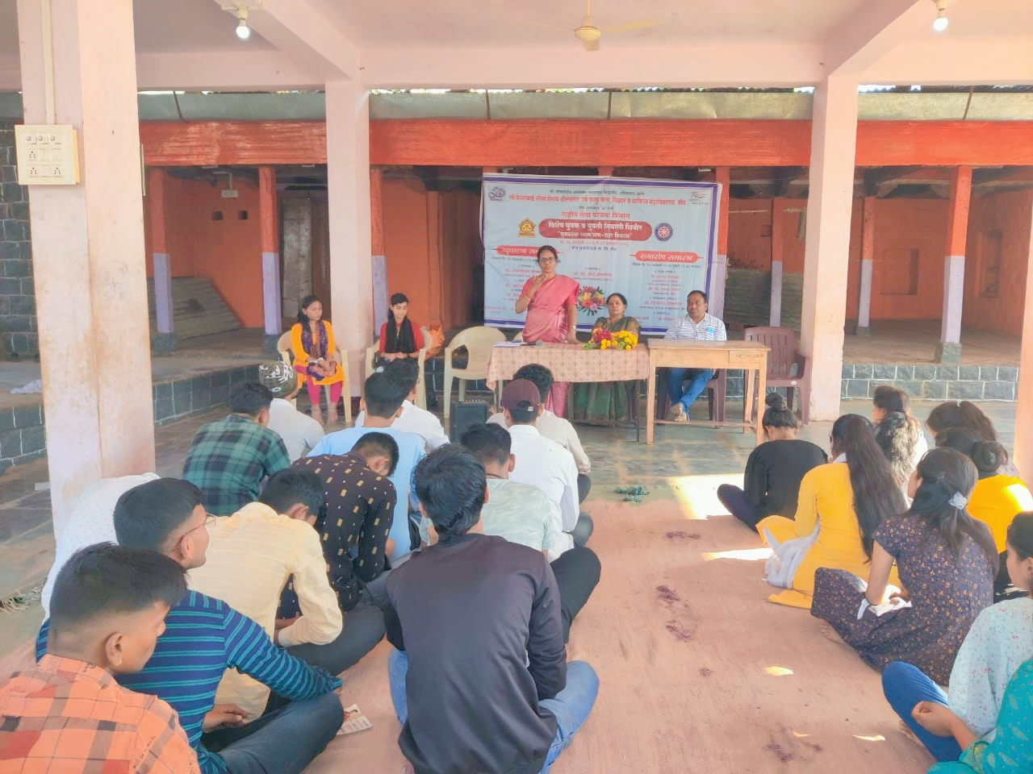
Dr. Pradnya Maheshmalkar Delivering a lecture on “Value of Freedom in the Constitution”, in the special youth and girls residential camp organized by NSS Dept. of college at Suryachi wadi Ta. Dist. Beed , dated on 18 jan. 2023 at 3.30 pm. On this occasion, Dr. Sandhya Jogdand, Programme officer Dr. Pandit Khakre,, Dr. Anita Shinde and Volunteers.
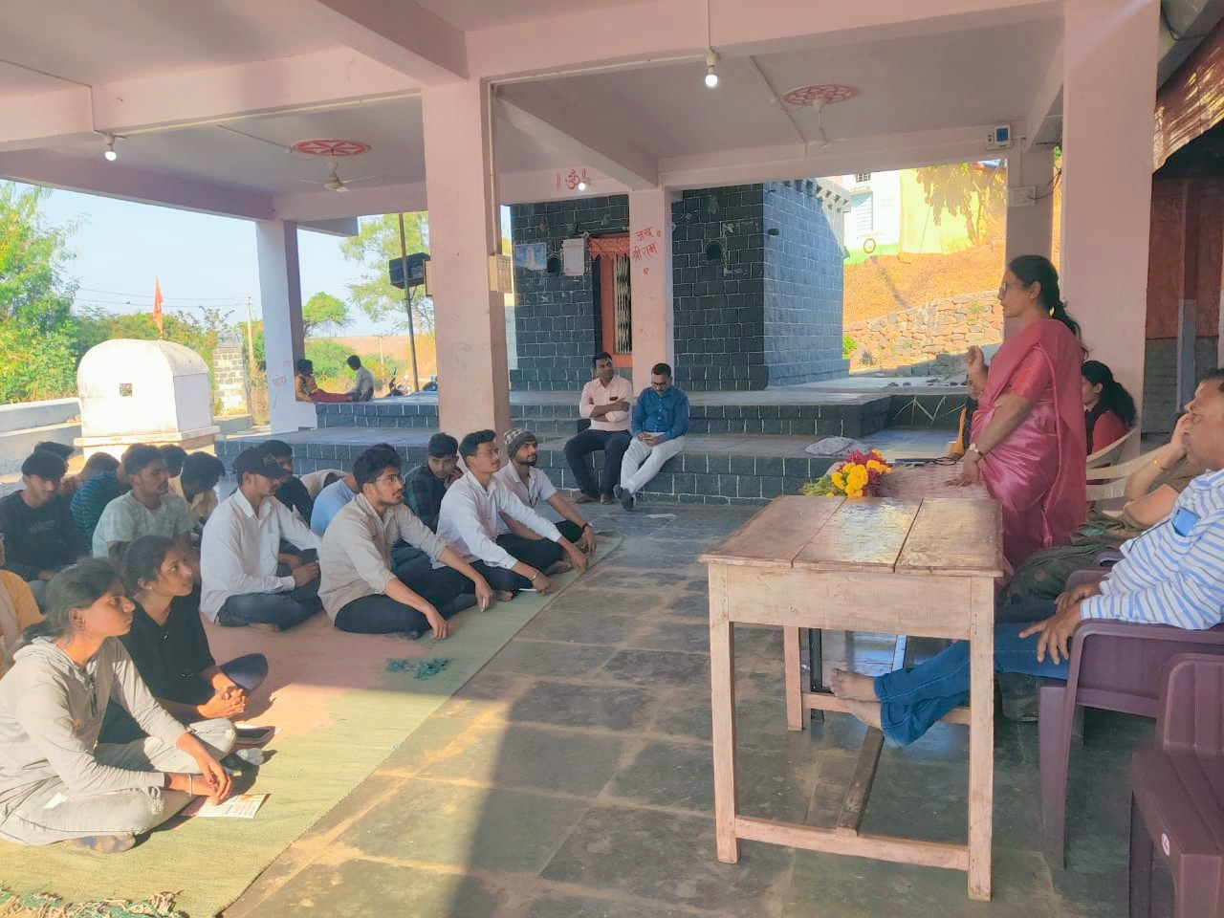
Dr. Pradnya Maheshmalkar Delivering a lecture on “Value of Freedom in the Constitution”, in the special youth and girls residential camp organized by NSS Dept. of college at Suryachi wadi Ta. Dist. Beed , dated on 18 jan. 2023 at 3.30 pm.On this occasion, Dr. Sandhya Jogdand, Programme officer Dr. Pandit Khakre,, Dr. Anita Shinde and Volenteers.

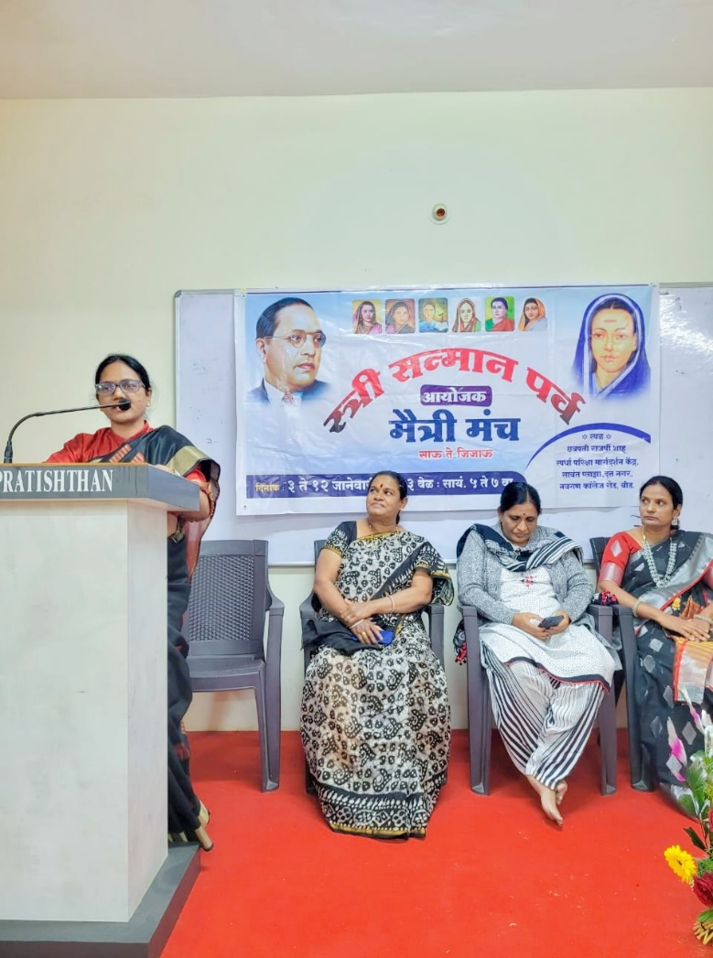
Dr. Pradnya Maheshmalkar Delivered a lecture on “Value of Freedom in the Constitution and Women”, organized by Maitrimanch Group. Dist. Beed , dated on 06 jan. 2023 at 6.30 pm.

Dr. Pradnya Maheshmalkar Delivered a lecture on “Tyagmurti Ramai Bhimrao Ambedkar yanchya Asim tyagachiPreranadaiGauravgatha”, on 5 feb.2023 , Sunday at 4.35 pm to 6.35 pm on googlemeet in online mode in 24thMahilaSammelan organized by Narishakti Manch.

